**EMC Test Report**

**for**

**{d.eutName}**

**ULR - TC522822000000051F**

**Test Report No.: TASL/17025/EMC/TRP/MIL/2223/009_1**



**This report shall not be reproduced without the written approval of EMC Centre Tata Advanced Systems. The test results stated in this report are valid only for the specific item tested under specific conditions and applied to the sample as received limited to the parameters monitored during the conduction of test**

**For any Complaints / Suggestions please email to:**

[**qmlabs@tataadvancedsystems.com**](mailto:qmlabs@tataadvancedsystems.com)

**This page is intentionally left blank**

**Amendment History**

|  |  |  |  |  |
| --- | --- | --- | --- | --- |
| **Revision No.** | **Date of Amend.** | **Amendment made** | **Reasons** | **Approved by** |
| * 1. 0 | 01/03/2021 | Laboratory name and logo, Tata power sed is replaced with Tata advanced systems limited | Due to organization name change from TPSED to TASL | QM |
| 2.0 | 05/04/2021 | Reference no updated for use of NABL Accredited CAB combined ILAC MRA Mark, included Test Report prepared by & EMC 32 software version is updated to 10.6 | To update Ref no provided by NABL for use of NABL Accredited CAB combined ILAC MRA Mark & Internal review of test report format | QM |
| 3.0 | 24/11/2021 | Updated ILAC MRA Mark symbol in the cover page of the report only by mentioning certificate No TC5228 | With ref to page no 59 of NABL newsletter Sep 2021 | QM |

**EMC CENTRE ACCREDIATION DETAILS**

The accreditation details in the below table

|  |  |
| --- | --- |
| **Accreditation Bodies** | **Certificate Number** |
| National Accreditation Board for Testing and Calibration Laboratories (NABL), as per ISO/IEC 17025 :2017  Agreement for use of NABL Accredited CAB combined ILAC MRA Mark | TC-5228  Ref No: NABL/ILAC/0876 |
| Telecommunication Engineering Centre (TEC)  Department of Telecommunications  Government of India | TEC/MRA/CAB/IND-D/15  CAB Identification: IND015 |

Table of Contents

1. General Information 6

2. Test Summary 7

3. Equipment under Test Description 10

4. Performance Monitoring Parameters 13

Annexure 1: CE101 - Conducted Emissions, Power Leads 14

Annexure 2: CE102 - Conducted Emissions, Power Leads 20

Annexure 3: RE101 - Radiated Emissions, Magnetic field 26

Annexure 4: RE102 - Radiated Emissions, Electric field 33

Annexure 5: CS101 - Conducted Susceptibility, Power Leads 38

Annexure 6: CS114 - Conducted Susceptibility, Bulk Cable injection 41

Annexure 7: CS115 - Conducted Susceptibility, Bulk Cable Injection, Impulse Excitation 44

Annexure 8: CS116 - Conducted Susceptibility, Damped Sinusoidal Transients. 46

Annexure 9: RS101 - Radiated Susceptibility, Magnetic Field 48

Annexure 10: RS103 - Radiated Susceptibility, Electric Field 53

**LIST OF FIGURES**

Figure 1 : EUT Functional Block Diagram 10

Figure 2 : EUT Photograph 11

Figure 3 : Photograph of EUT Name and Serial No. 11

Figure 4 : Photograph of EUT Set up Configuration 12

Figure 5 : Photograph of Performance Monitoring 13

Figure 6 : CE101-2. CE101 Limit for Surface Ships and Submarine Application 15

**Figure 7 : CE101 Test Setup Photograph** 19

Figure 8 : CE102 Limit line (440V) 21

Figure 9 : CE102 Test Setup Photograph 25

Figure 10 : RE101 Limit Line (Navy Applications) 27

Figure 11 : RE101 Test Setup Photograph 32

Figure 12 : RE102-1 Limit Line for Surface Ship Applications 34

Figure 13 : RE102 Test Setup Photograph 37

Figure 14 : CS101 Limit (Curve # 1) 39

Figure 15 : CS101 Test Setup Photograph 40

Figure 16 : CS114 Limit (Curve #2) 42

Figure 17 : CS114 Test Setup Photograph 43

Figure 18 : CS115 Limit 45

Figure 19 : CS115 Test Setup Photograph 45

Figure 20 : CS116 Limit (IMAX – 10 Amps) 47

Figure 21 : CS116 Test Setup Photograph 47

Figure 22 : RS101 Limit (Navy applications) 49

Figure 23 : RS101 Test Setup Photograph 52

Figure 24 : RS103 Test Setup Photograph 59

**LIST OF GRAPHS**

Graph 1 : CE101 – Ambient Graph 15

Graph 2 : CE101 – R Phase (Group-1) 16

Graph 3 : CE101 – Y Phase (Group-1) 16

Graph 4 : CE101 – B Phase (Group-1) 17

Graph 5 : CE101 – R Phase (Group-2) 17

Graph 6 : CE101 – Y Phase (Group-2) 18

Graph 7 : CE101 – B Phase (Group-2) 18

Graph 8 : CE102 – Ambient Graph 21

Graph 9 : CE102 – R Phase (Group-1) 22

Graph 10 : CE102 – Y Phase (Group-1) 22

Graph 11 : CE102 – B Phase (Group-1) 23

Graph 12 : CE102 – R Phase (Group-2) 23

Graph 13 : CE102 – Y Phase (Group-2) 24

Graph 14 : CE102 – B Phase (Group-2) 24

Graph 15 : RE101- Ambient Graph 27

Graph 16 : RE101- Position 1 (EUT Front Side) 28

Graph 17 : RE101 – Position 2 (EUT Right Side) 28

Graph 18 : RE101 – Position 3 (EUT Back Side) 29

Graph 19 : RE101 – Position 4 (EUT Left Side) 29

Graph 20 : RE101 – Position 5 (EUT Top Side) 30

Graph 21 : RE102 – Ambient Graph 34

Graph 22 : RE102 – 10 kHz to 1GHz Vertical Polarization 35

Graph 23 : RE102 – 30MHz to 1GHz Horizontal Polarization 35

Graph 24 : CS101 Field Level (dBµV) 40

Graph 25 : CS114 – 10kHz to 200MHz - Immunity Level (dBµA) Curve #2 43

Graph 26 : RS101 – Immunity Level (dBpT) 49

Graph 27: RS103 –2MHz to 80MHz - Field Strength in V/m 54

Graph 28: RS103 –2MHz to 80MHz - Forward Power in Watts 55

Graph 29: RS103 –80MHz to 200MHz - Field Strength in V/m 55

Graph 30: RS103 –80MHz to 200MHz - Forward Power in Watts 56

Graph 31: RS103 200MHz to 1000MHz - Field Strength in V/m 56

Graph 32: RS103 –200MHz to 1000MHz - Forward Power in Watts 57

Graph 33: RS103 –1GHz to 18GHz - Field Strength in V/m 57

Graph 34: RS103 – 1GHz to 18GHz - Forward Power in dBm 58

# General Information

|  |  |  |
| --- | --- | --- |
| **Name of the Applicant** | {d.companyName} | |
| **Contact Name** | {d.firstName} {d.lastName} | |
| **Contact No** | {d.contactNo} | |
| **Email id** | [{](mailto:anikhil@tuv-nord.com)d.emailId} | |
| **EUT Manufacturer**  **Name and Address** | {d.manufacturer} | |
| **EUT Name** | {d.eutName} | |
| **Model No** | {d.modelNo} | |
| **Serial No** | A19/060 | |
| **Supply Voltage & Current** | 380V, 3-Phase, 50Hz AC Supply & 9.6 Amps | |
| **Test Location** | M/s.TASL, 42 - 43 Electronics City Hosur Road, Bengaluru - 560100. | |
| **Tests Conducted** | {d.allTestName} | |
| **Test Standard** | MIL-STD-461E | |
| **Status of EUT on receipt** | EUT was received in Good Condition | |
| **EUT Received on** | 27/04/2022 | |
| **Dates of Test** | 29/04/2022-30/04/2022 | |
| **Test Report Issued on** | 14/02/2022 | |
| **Test witnessed by** | Ms. Sakthivel S (M/s. TUV INDIA PRIVATE LIMITED) | |
| **Test Result** | Pass | |
| **Statement of conformity** | Declaration of conformity of the results are based as per the std limits | |
| **Test Report Prepared** | Rajeshkumar N | |
| **Test Engineer and Reviewer Details** | | |
| **Tested by**  **Akhilesh Sidapara**  **Test Engineer** | **Reviewed by**  **R Munusamy**  **Lab in Charge** | **Authorized by**  **J Gopinathan**  **Technical Manager** |

***Note: This report is digitally signed by the approving authority through a secured workflow***

# Test Summary

## electronics testing

## emc testing

| **Emission Tests** | | | |
| --- | --- | --- | --- |
| **Sl. No** | **Name of the Tests** | **Limits** | **Results** |
|  | CE101-Conducted Emissions, Power Leads, 30Hz to 10kHz | CE101-2, Limit for Submarines and Surface Ship Applications | Pass  Refer Annex-1 |
|  | CE102-Conducted Emissions, Power Leads, 10kHz to 10MHz | CE102-1, For 440V Applications | Pass  Refer Annex-2 |
|  | RE101- Radiated Emissions, Magnetic field, 30Hz to 100kHz | RE101-2, Navy applications | Pass  Refer Annex-3 |
|  | RE102- Radiated Emissions, Electric field, 10kHz to 1 GHz | RE102-1, Limit Line for Surface Ship Applications (Below Deck) | Pass  Refer Annex-4 |

| **Susceptibility Tests** | | | |
| --- | --- | --- | --- |
| **Sl. No** | **Name of the Test** | **Limits** | **Results** |
|  | CS101-Conducted Susceptibility, Power Leads, 30Hz to 150kHz | CS101 -1, Voltage Limit  (Curve #1) | Pass  Refer Annex-5 |
|  | CS114-Conducted Susceptibility, Bulk Cable injection, 10kHz to 200MHz | CS114 -1, Curve #2 | Pass  Refer Annex-6 |
|  | CS115-Conducted susceptibility, Bulk Cable Injection, Impulse Excitation. | CS115-1, I = 5 Amps  (For All Applications) | Pass  Refer Annex-7 |
|  | CS116 - Conducted Susceptibility, Damped sinusoidal Transients, Cable and power Leads, 10kHz to 100MHz | CS116-2 IMAX = 10 Amps  (Navy Applications) | Pass  Refer Annex-8 |
|  | RS101- Radiated Susceptibility, Magnetic field, 30Hz – 100kHz | RS101-1, Navy Applications | Pass  Refer Annex-9 |
|  | RS103- Radiated Susceptibility, Electric field, 2MHz – 18GHz | 10 V/m Pulse modulated at a  1kHz rate with a 50% duty cycle | Pass  Refer Annex-10 |

## Measurement uncertainty

The following measurement uncertainties are applicable to the relevant tests that are mentioned below:

|  |  |  |
| --- | --- | --- |
| **Test** | | **Uncertainty (±)** |
| CE101 | | ±2.368dB |
| CE102 | | ±1.829dB |
| RE101 | | ±2.16dB |
| RE102 | Below 1GHz | ±3.851dB |
| Above 1GHz | ±3.671dB |

## 

## Opinions& interpretation

None

## Deviation from STANDARD

None

# Equipment under Test Description

The Auto changeover switch 130A-185 A and 250A-300A are used for automatic changeover to Alternate supply when Normal supply falls below a set level. When the Normal supply resumes above another set level, it changes over again to Normal supply. The Dwell time (OFF TIME) between the changeovers is adjustable from 0.1 sec. to 0.8 sec. +/- 20%. The manual changeover is possible if electronic circuit fails. The input supply to this system is Normal Supply & Alternate Supply 380VAC, 50 Hz. These equipments will be installed in metallic surface ship below deck.

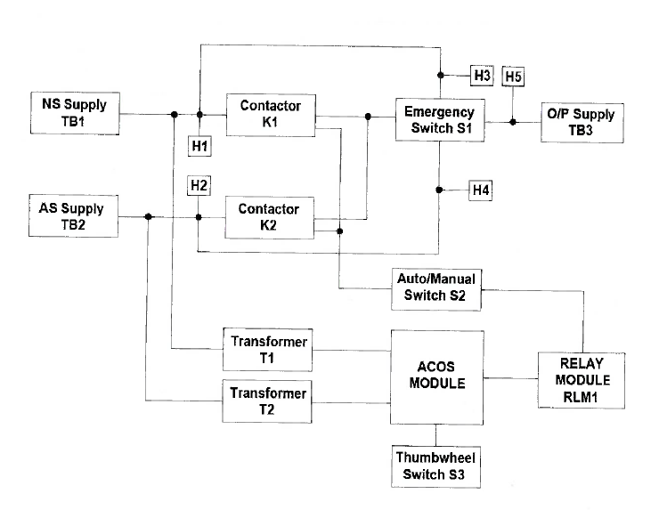

**Figure 1 : EUT Functional Block Diagram**

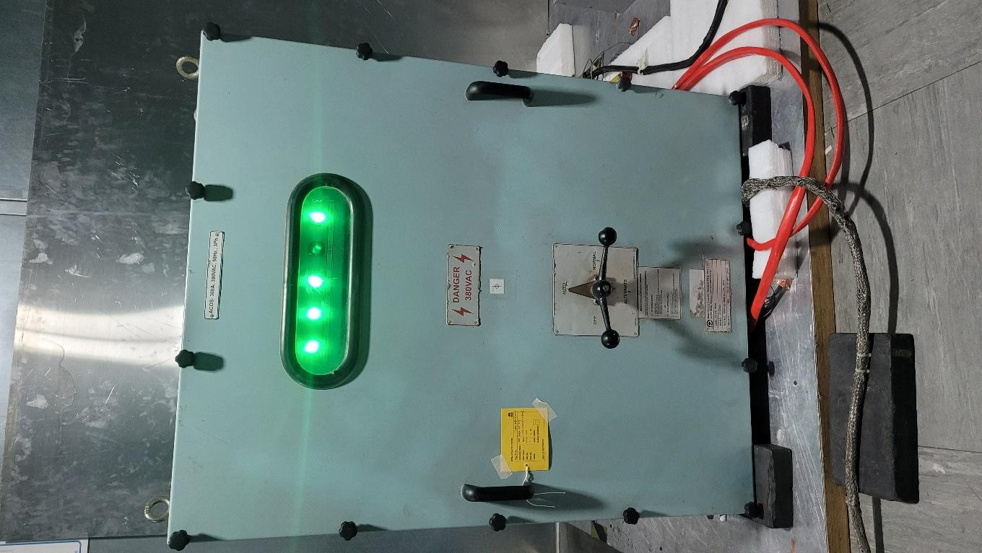

**Figure 2 : EUT Photograph**

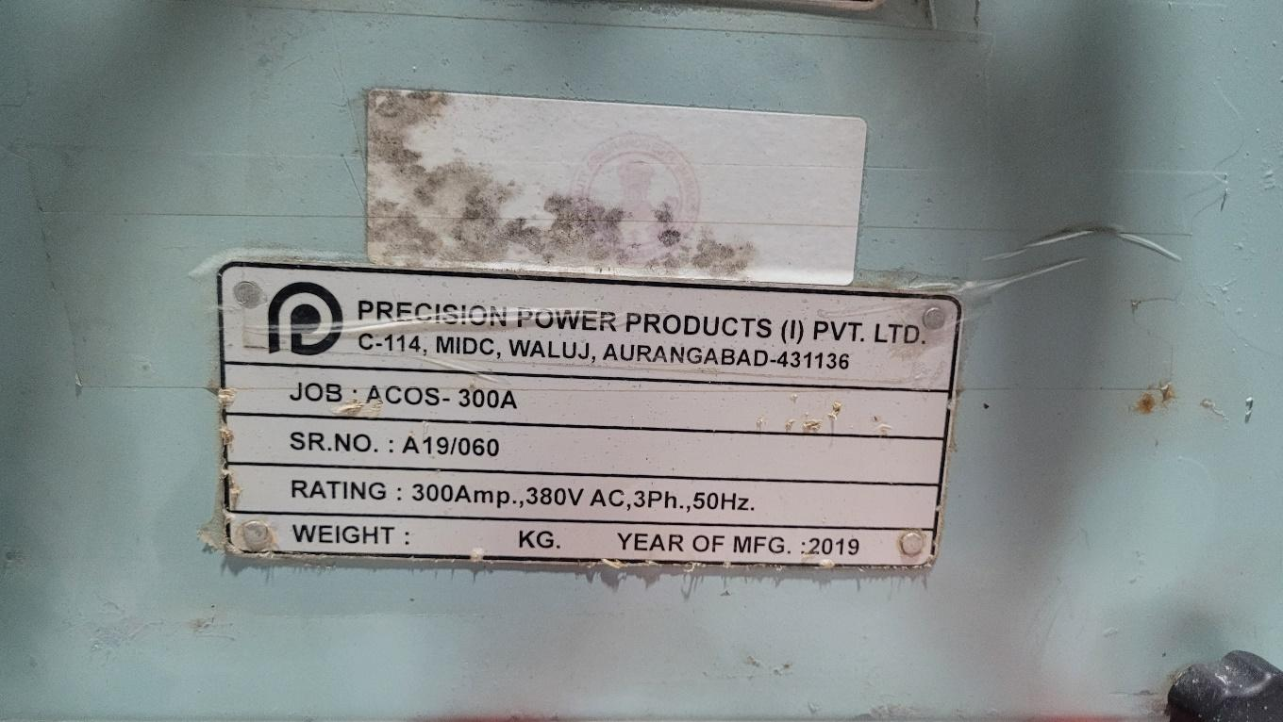

**Figure 3 : Photograph of EUT Name and Serial No.**

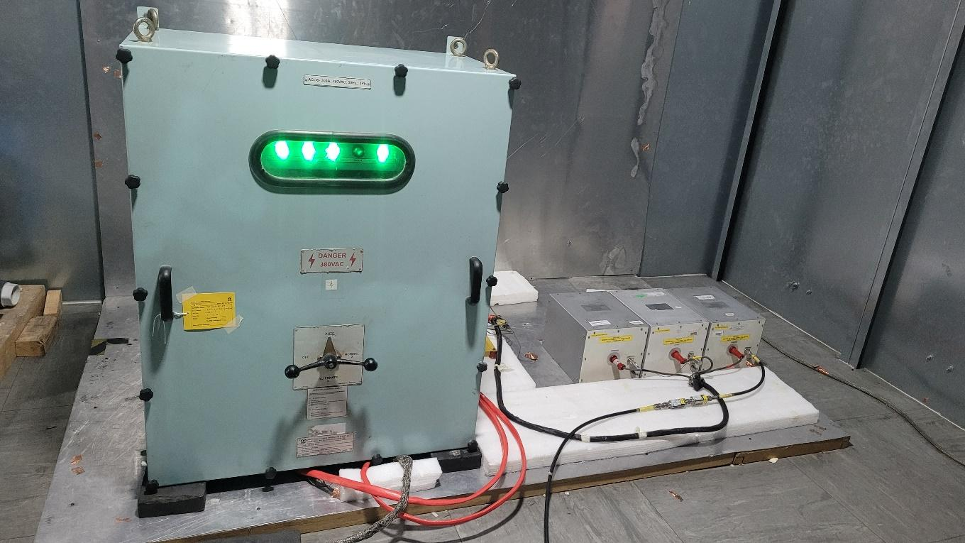

**Figure 4 : Photograph of EUT Set up Configuration**

# Performance Monitoring Parameters

During the testing the following parameters were monitored.

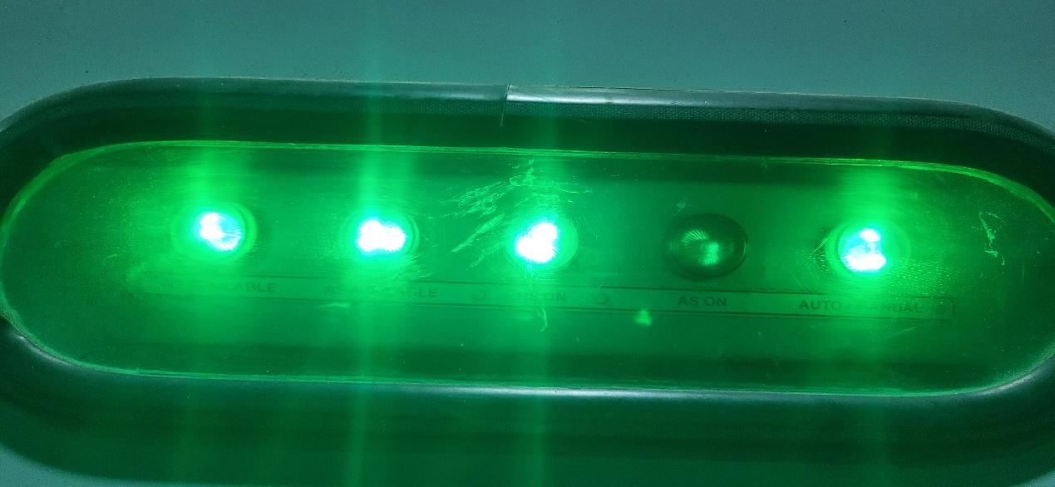

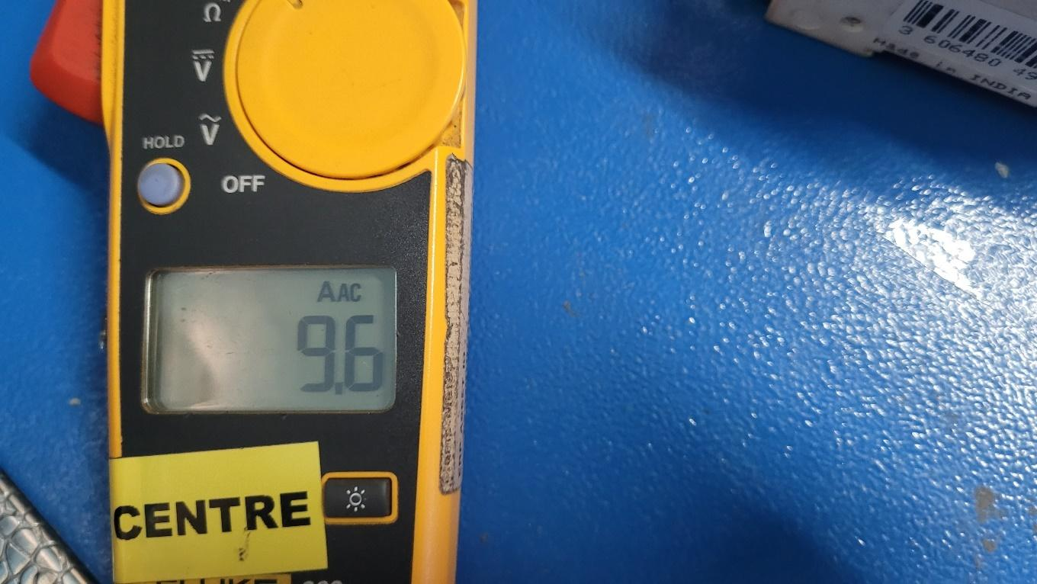

**Figure 5 : Photograph of Performance Monitoring**

# Annexure 1: CE101 - Conducted Emissions, Power Leads

**Common Information:**

Ref EMC Test Plan : PPPL/EMI-EMC/ACOS(V)2019/03

Test Standard : MIL-STD 461E

Test Date : 29/04/2022

Test mode : 380V AC & 9.6 Amps

Software used : EMC32 Ver_8.54

Temperature : 25ºC

Humidity : 60%



**Test Equipment Used :**

|  |  |  |  |  |  |
| --- | --- | --- | --- | --- | --- |
| **Sl. No.** | **Description** | **Make** | **Model No.** | **Serial No.** | **Cal Due** |
| 1. | EMI Receiver | R&S | ESU40 | 100187 | 04-09-2022 |
| 2. | Current Probe | ETS | 91197 | 00081423 | 02/06/2022 |
| 3. | LISN | Solar | 9233-50-PJ-50-N | 98361 & 98363  98362 | 01/12/2023  02/12/2023 |

**Receiver Settings**:

|  |  |  |  |  |
| --- | --- | --- | --- | --- |
| **Subrange** | **Detectors** | **IF Bandwidth** | **Meas. Time** | **Receiver** |
| 30Hz- 1kHz | Peak | 10Hz | 0.15s | ESU40 |
| 1kHz- 10kHz | Peak | 100Hz | 0.015s | ESU40 |

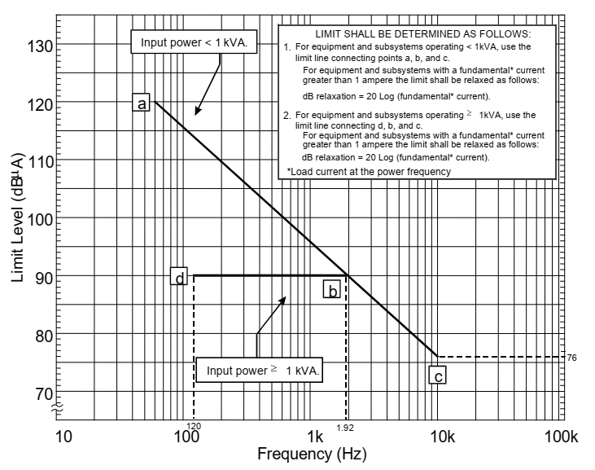

**Figure 6 : CE101-2. CE101 Limit for Surface Ships and Submarine Application**

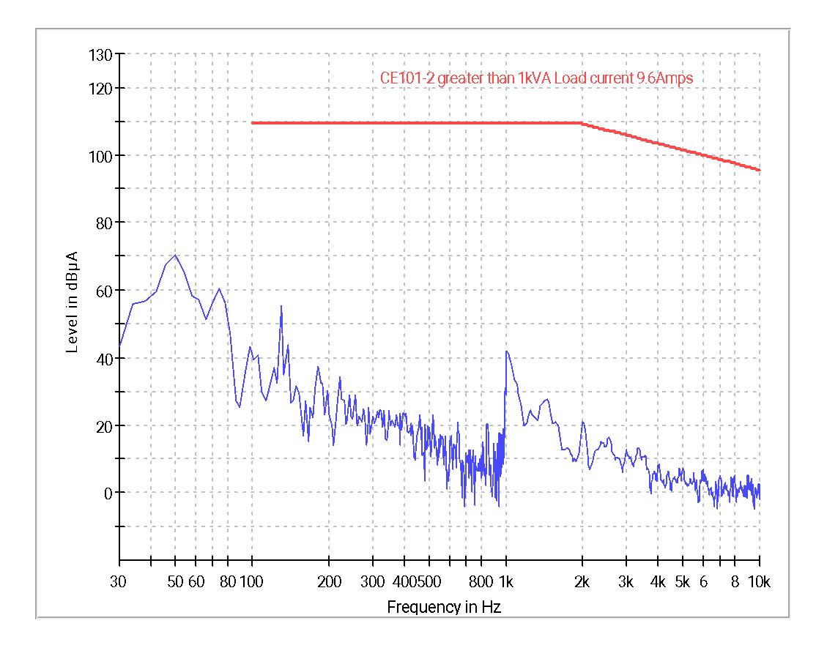

**Graph 1 : CE101 – Ambient Graph**

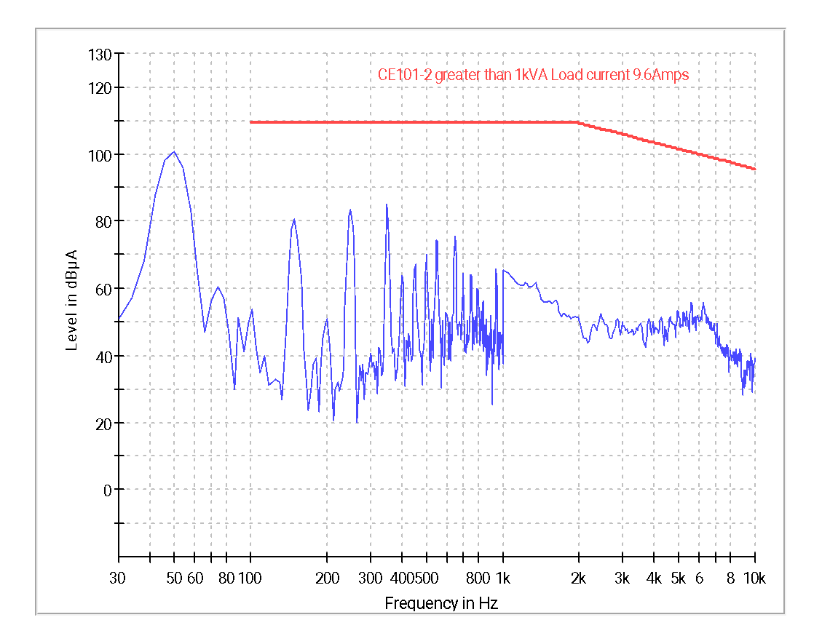

**Graph 2 : CE101 – R Phase (Group-1)**

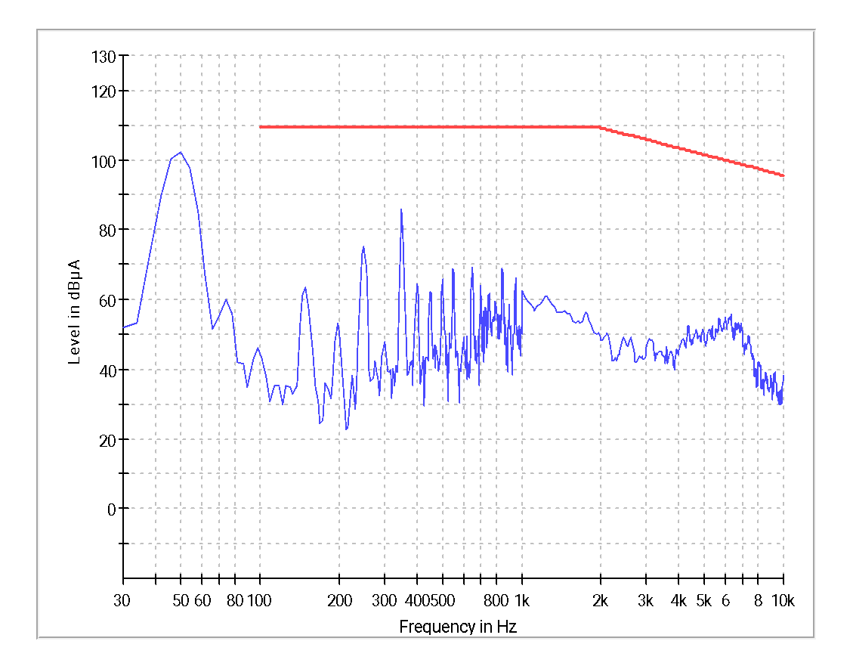

**Graph 3 : CE101 – Y Phase (Group-1)**

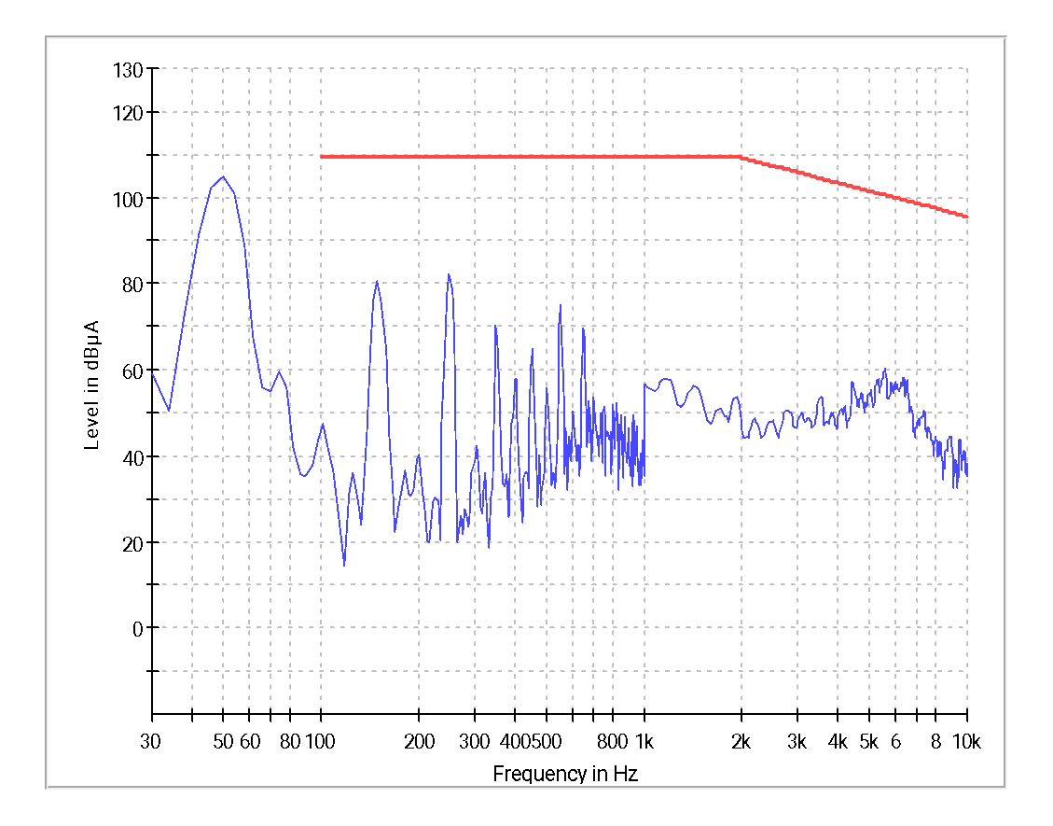

**Graph 4 : CE101 – B Phase (Group-1)**

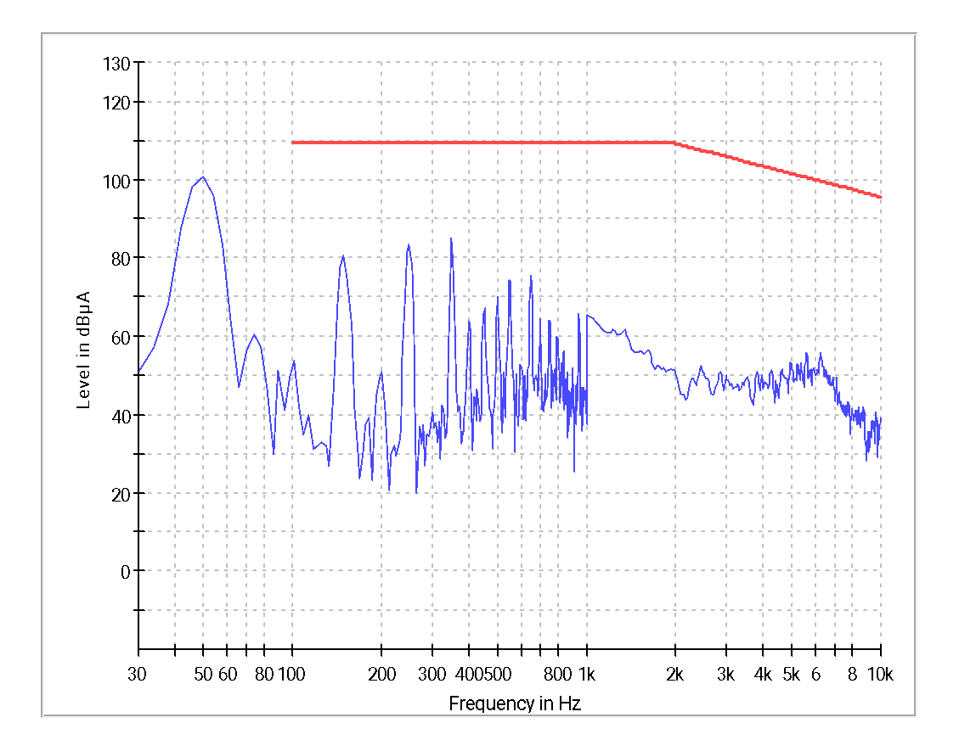

**Graph 5 : CE101 – R Phase (Group-2)**



**Graph 6 : CE101 – Y Phase (Group-2)**



**Graph 7 : CE101 – B Phase (Group-2)**

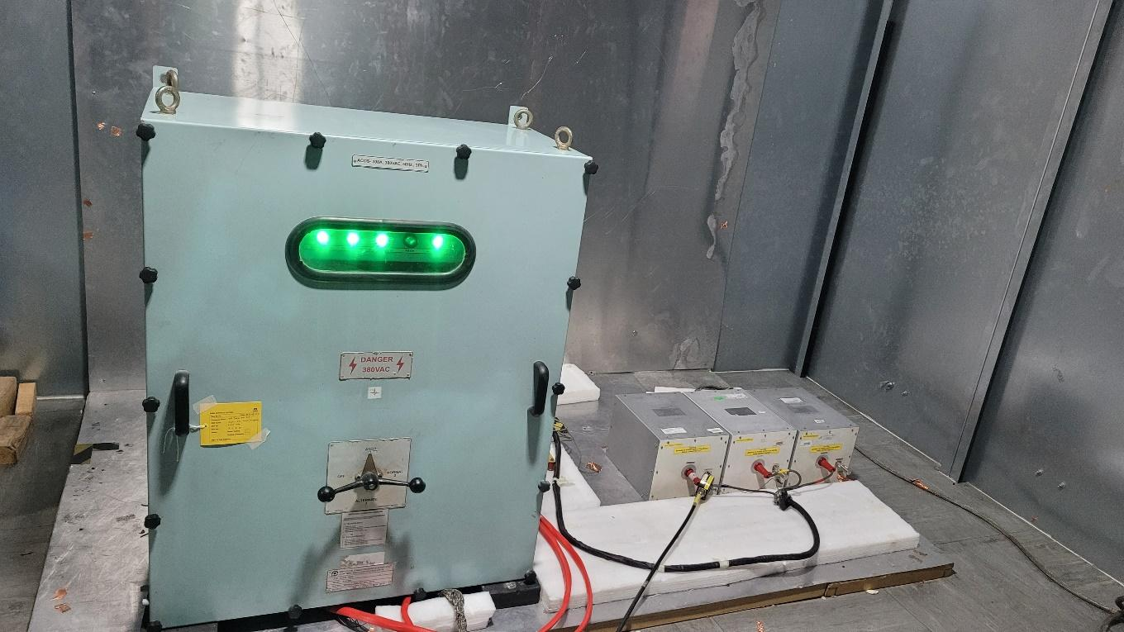

**Figure 7 : CE101 Test Setup Photograph**

|  |  |
| --- | --- |
| **Test Result** | **Pass** |

# Annexure 2: CE102 - Conducted Emissions, Power Leads

**Common Information:**

Ref EMC Test Plan : PPPL/EMI-EMC/ACOS(V)2019/02

Test Standard : MIL-STD 461E

Test Date : 29/04/2022

Test mode : 380V AC & 9.6 Amps

Software used : EMC32 Ver_8.54

Temperature : 25.5ºC

Humidity : 61%



**Test Equipment Used :**

|  |  |  |  |  |  |
| --- | --- | --- | --- | --- | --- |
| **Sl. No.** | **Description** | **Make** | **Model No.** | **Serial No.** | **Cal Due** |
| 1. | EMI Receiver | R&S | ESU40 | 100187 | 04-09-2022 |
| 2. | Pulse Limiter | R&S | ESH3-Z2 | 101128,  101090 | 26/07/2023 |
| 3. | LISN | Solar | 9233-50-PJ-50-N | 98361 & 98363  98362 | 01/12/2023  02/12/2023 |

**Receiver Settings**:

|  |  |  |  |  |
| --- | --- | --- | --- | --- |
| **Subrange** | **Detectors** | **IF Bandwidth** | **Meas. Time** | **Receiver** |
| 10kHz- 150kHz | Peak | 1 kHz | 0.015s | ESU40 |
| 150kHz- 10MHz | Peak | 10 kHz | 0.015s | ESU40 |

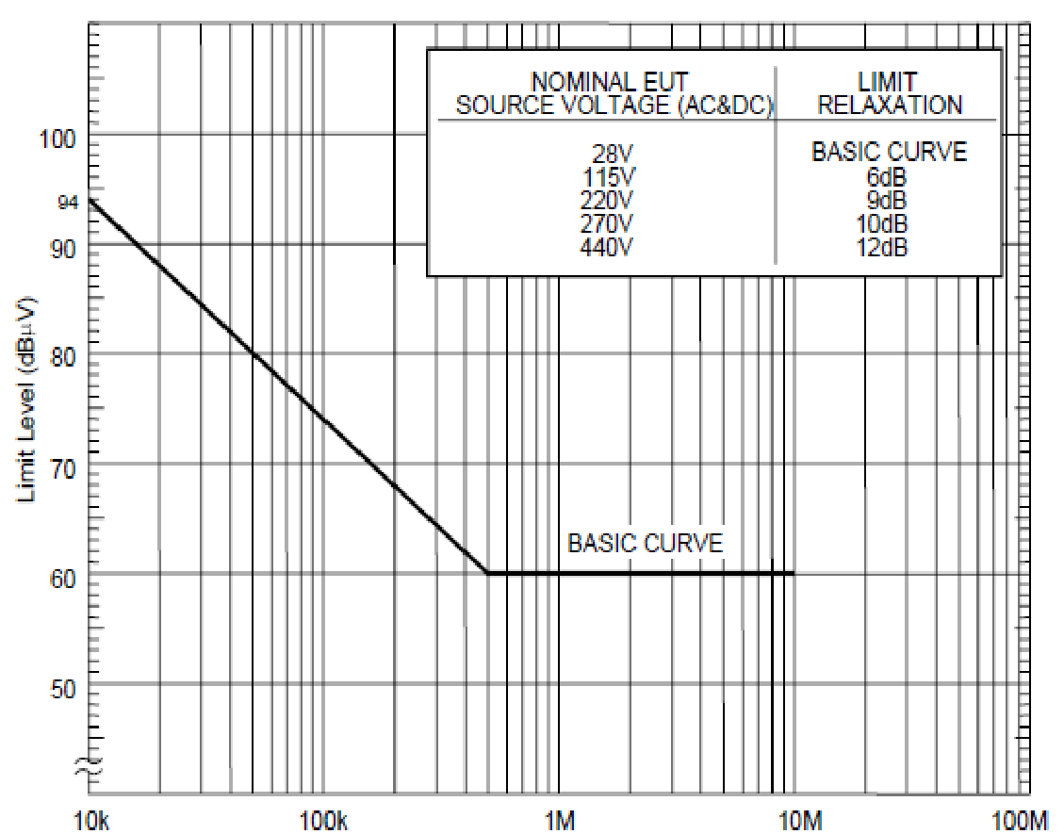

**Figure 8 : CE102 Limit line (440V)**

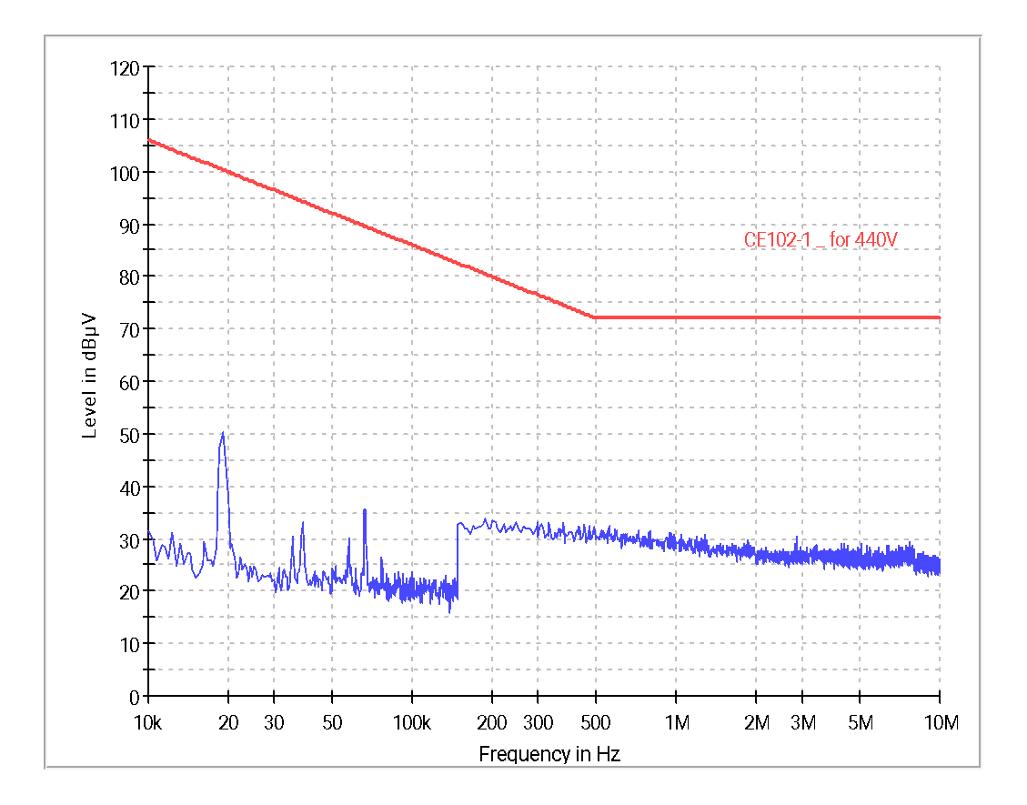

**Graph 8 : CE102 – Ambient Graph**

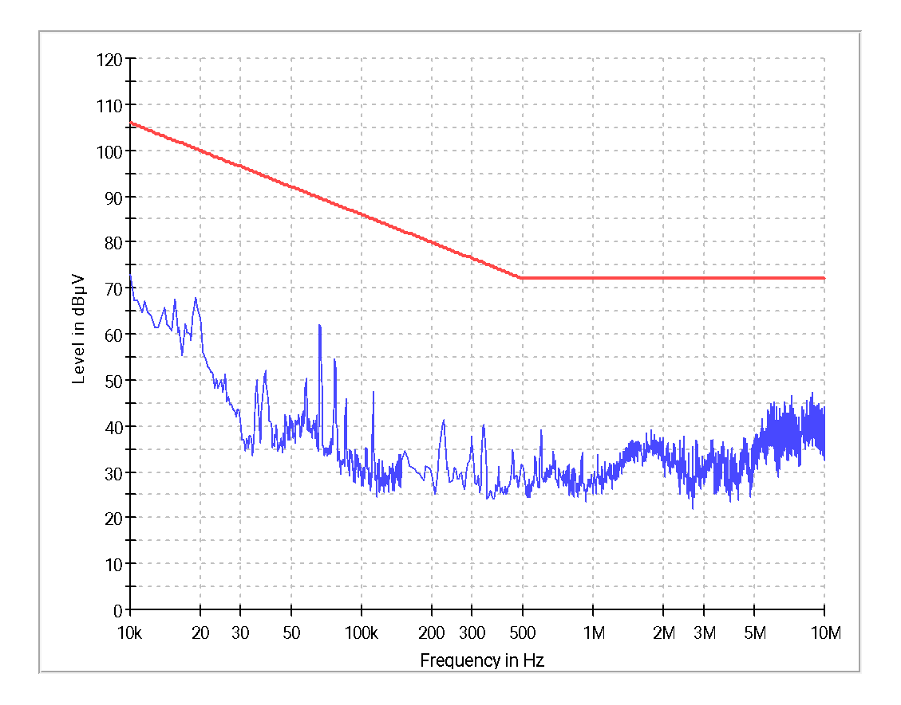

**Graph 9 : CE102 – R Phase (Group-1)**

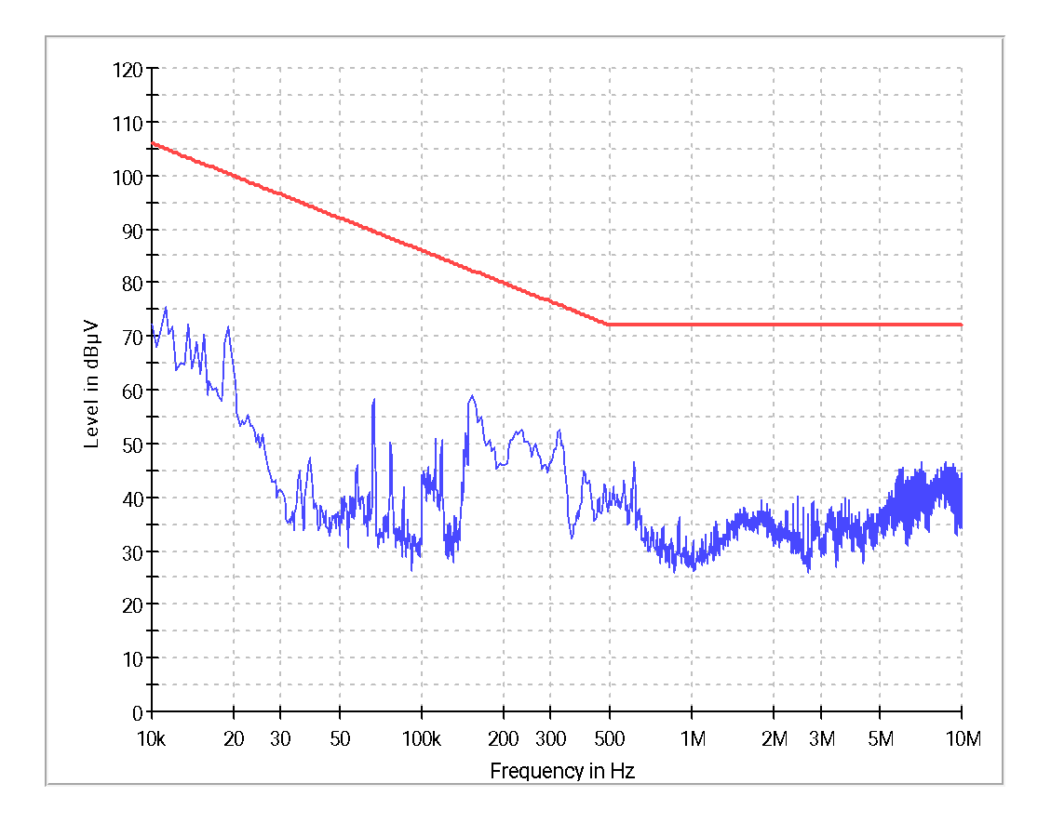

**Graph 10 : CE102 – Y Phase (Group-1)**

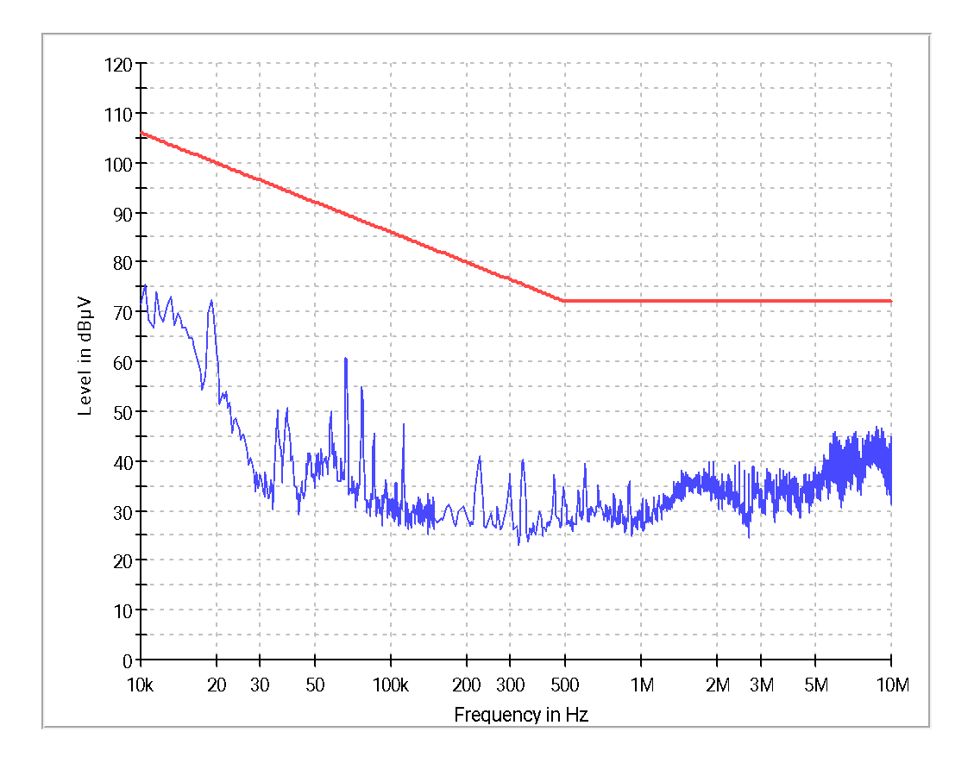

**Graph 11 : CE102 – B Phase (Group-1)**



**Graph 12 : CE102 – R Phase (Group-2)**



**Graph 13 : CE102 – Y Phase (Group-2)**



**Graph 14 : CE102 – B Phase (Group-2)**

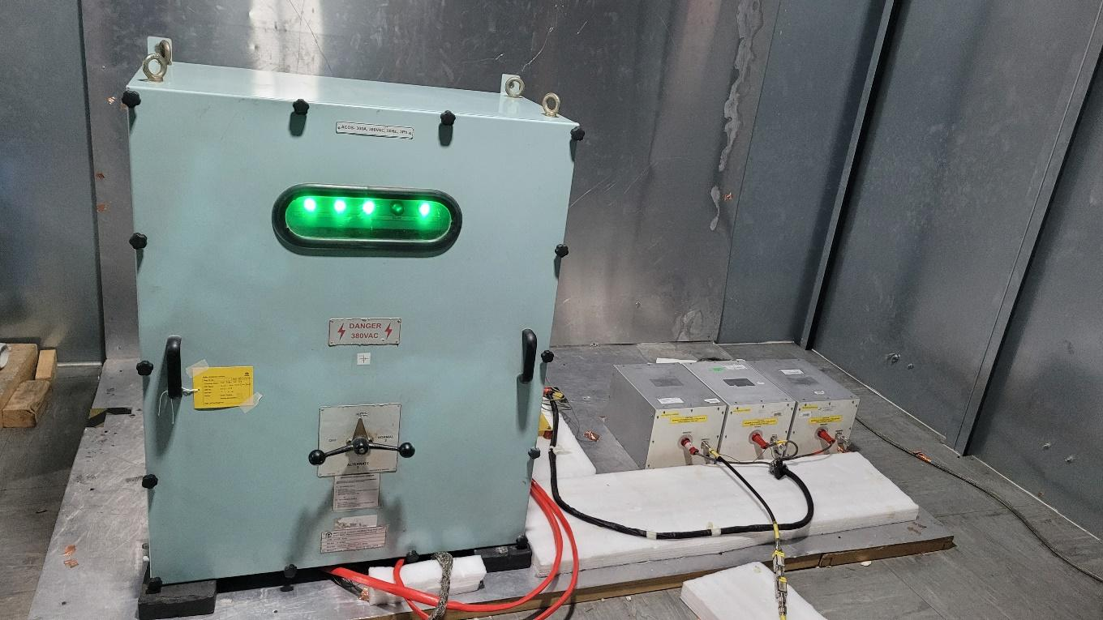

**Figure 9 : CE102 Test Setup Photograph**

|  |  |
| --- | --- |
| **Test Result** | **Pass** |

# Annexure 3: RE101 - Radiated Emissions, Magnetic field

**Common Information:**

Ref EMC Test Plan : PPPL/EMI-EMC/ACOS(V)2019/02

Test Standard : MIL-STD 461E

Test Date : 29/04/2022

Test mode : 380V AC & 9.6 Amps

Software used : EMC32 Ver_8.54

Temperature : 26ºC

Humidity : 60%



**Test Equipment Used :**

|  |  |  |  |  |  |
| --- | --- | --- | --- | --- | --- |
| **Sl. No.** | **Description** | **Make** | **Model No.** | **Serial No.** | **Cal Due** |
|  | Main Chamber | Rain Ford | 467 001 | -- | 02/06/2022 |
|  | EMI Receiver | R&S | ESU40 | 100187 | 04-09-2022 |
|  | Magnetic Field Pick up coil | R&S | HZ-10 | 100155 | 23/04/2022 |
|  | LISN | Solar | 9233-50-PJ-50-N | 98361 & 98363  98362 | 01/12/2023  02/12/2023 |

**Receiver Settings:**

|  |  |  |  |  |
| --- | --- | --- | --- | --- |
| **Subrange** | **Detectors** | **IF Bandwidth** | **Meas. Time** | **Receiver** |
| 30Hz-1kHz | Peak | 10Hz | 0.15s | ESU40 |
| 1kHz-10kHz | Peak | 100Hz | 0.015s | ESU40 |
| 10kHz-100kHz | Peak | 1 kHz | 0.015s | ESU40 |

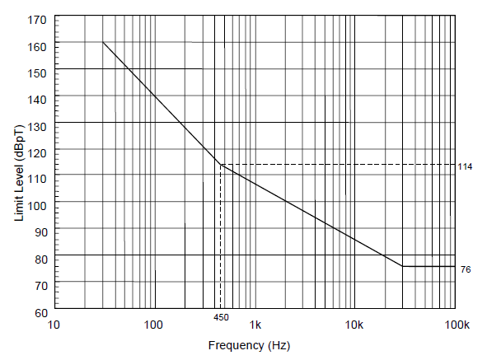

**Figure 10 : RE101 Limit Line (Navy Applications)**

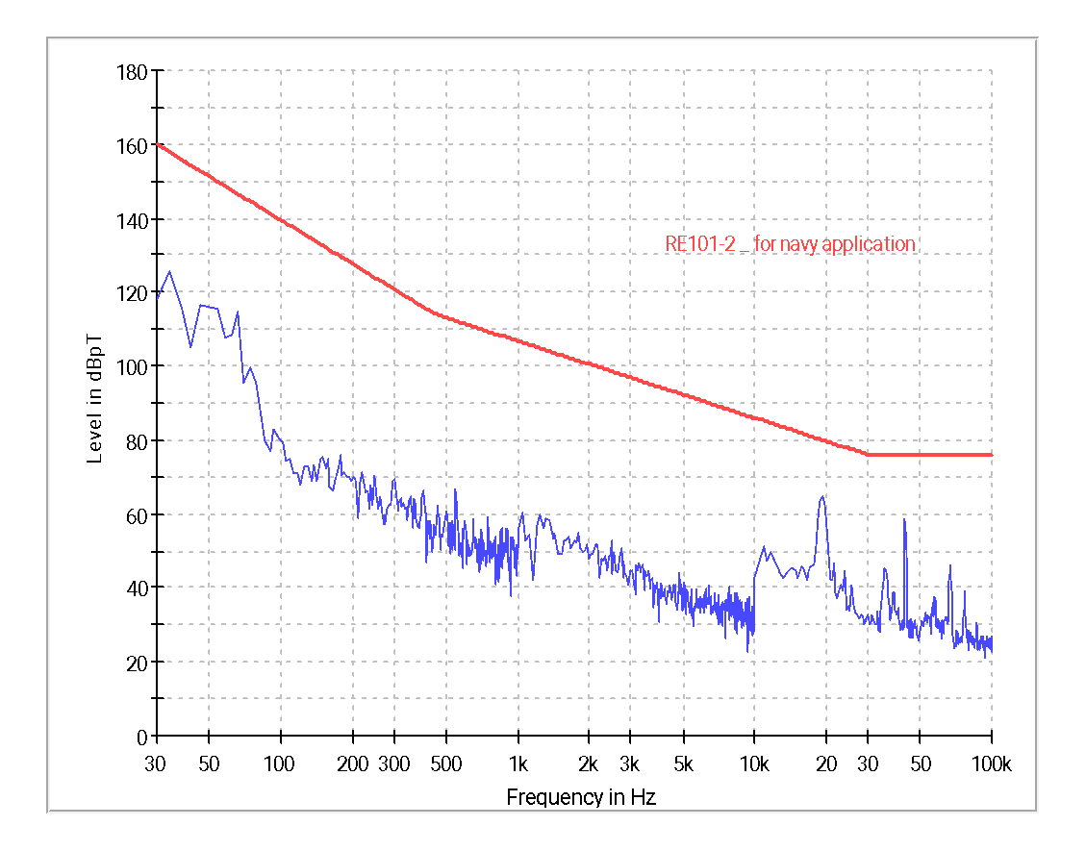

**Graph 15 : RE101- Ambient Graph**

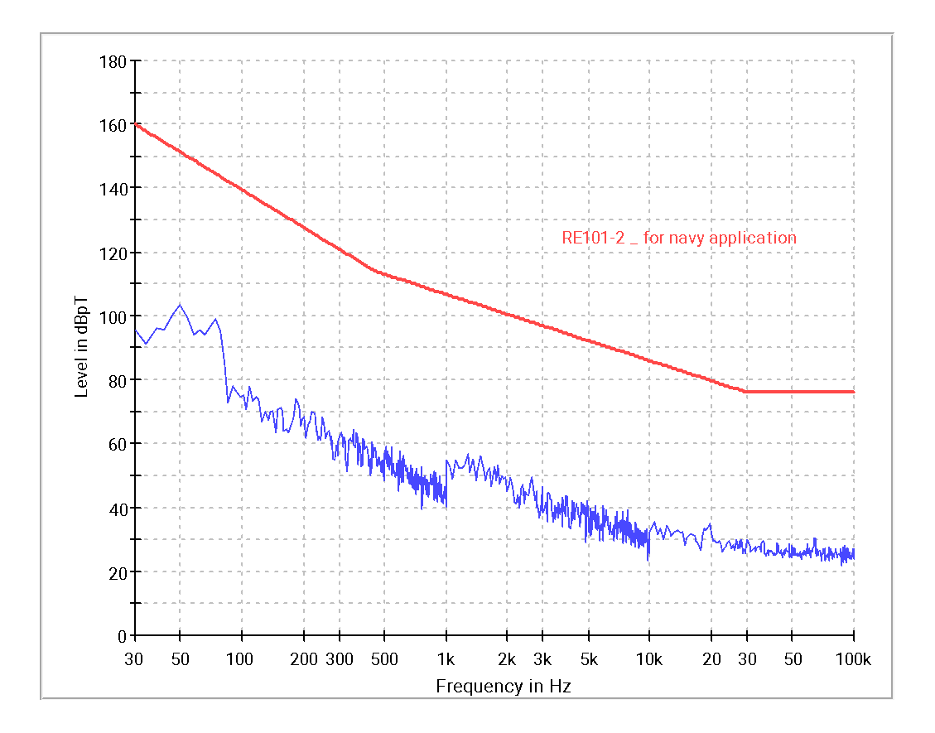

**Graph 16 : RE101- Position 1 (EUT Front Side)**

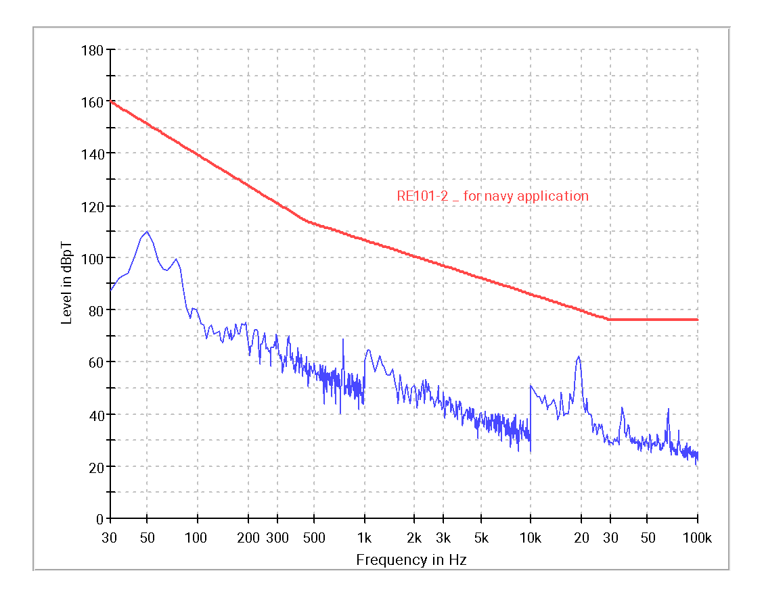

**Graph 17 : RE101 – Position 2 (EUT Right Side)**

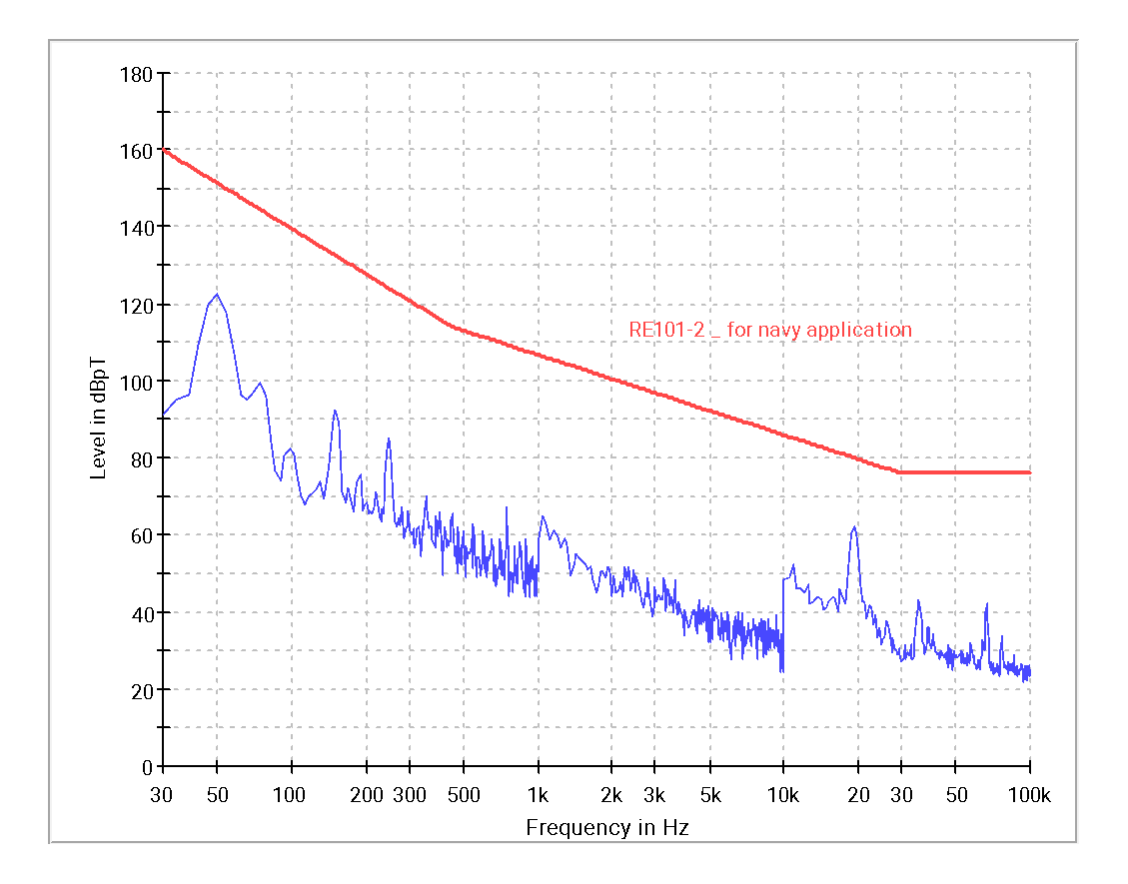

**Graph 18 : RE101 – Position 3 (EUT Back Side)**

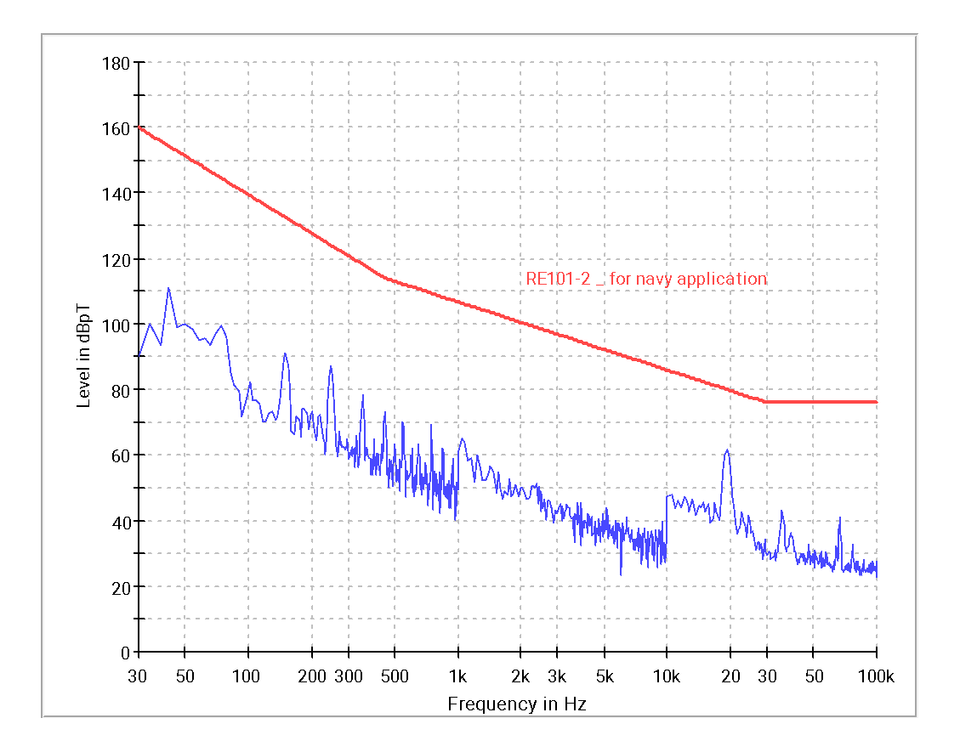

**Graph 19 : RE101 – Position 4 (EUT Left Side)**

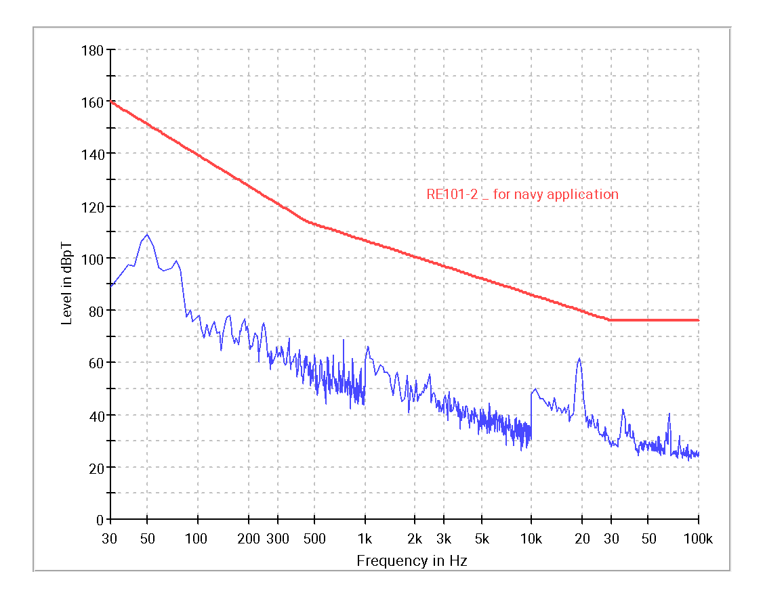 ‘

**Graph 20 : RE101 – Position 5 (EUT Top Side)**

|  |
| --- |
| **EUT Front Side** |

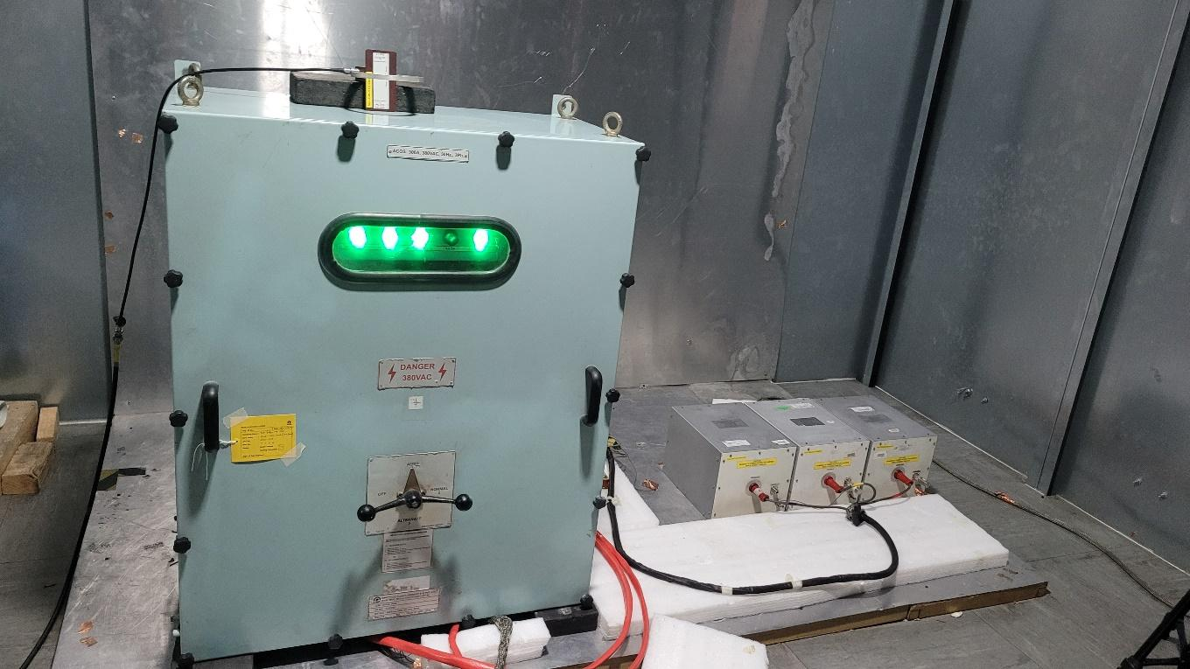

EUT TOP

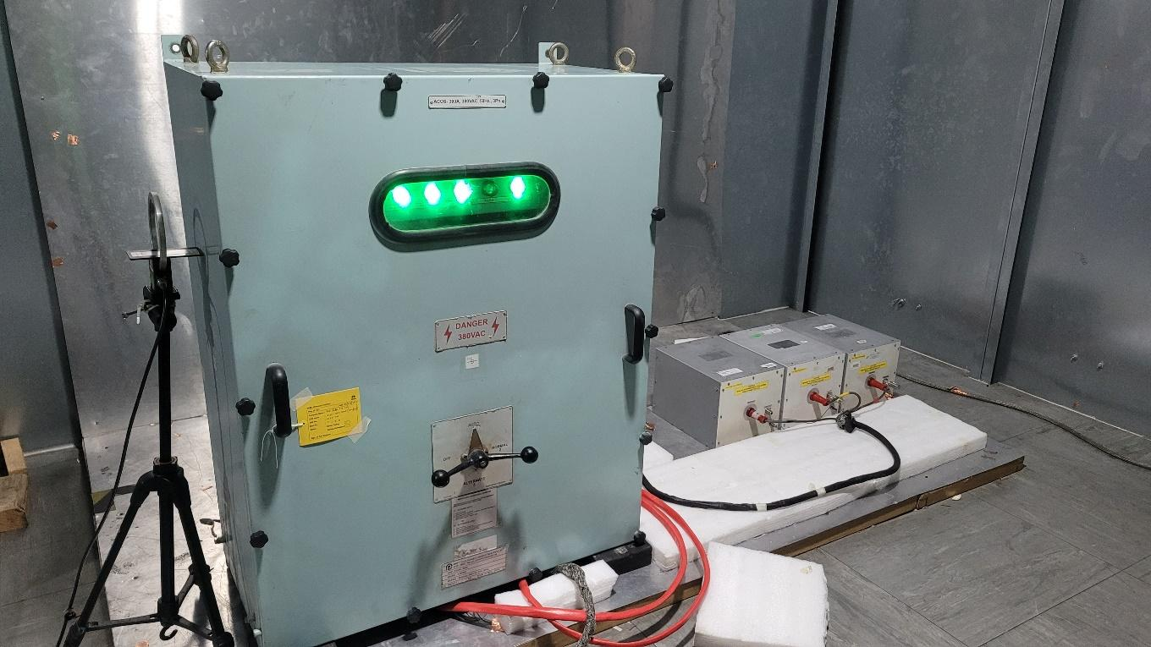

EUT LEFT

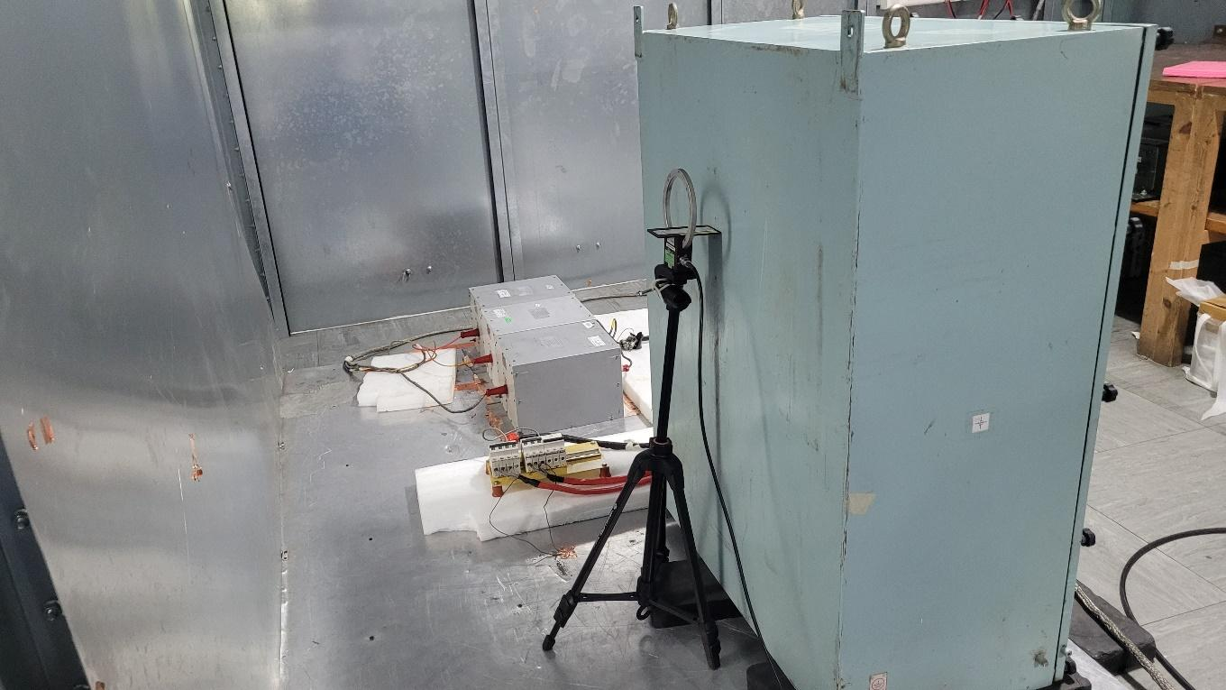

EUT BACK

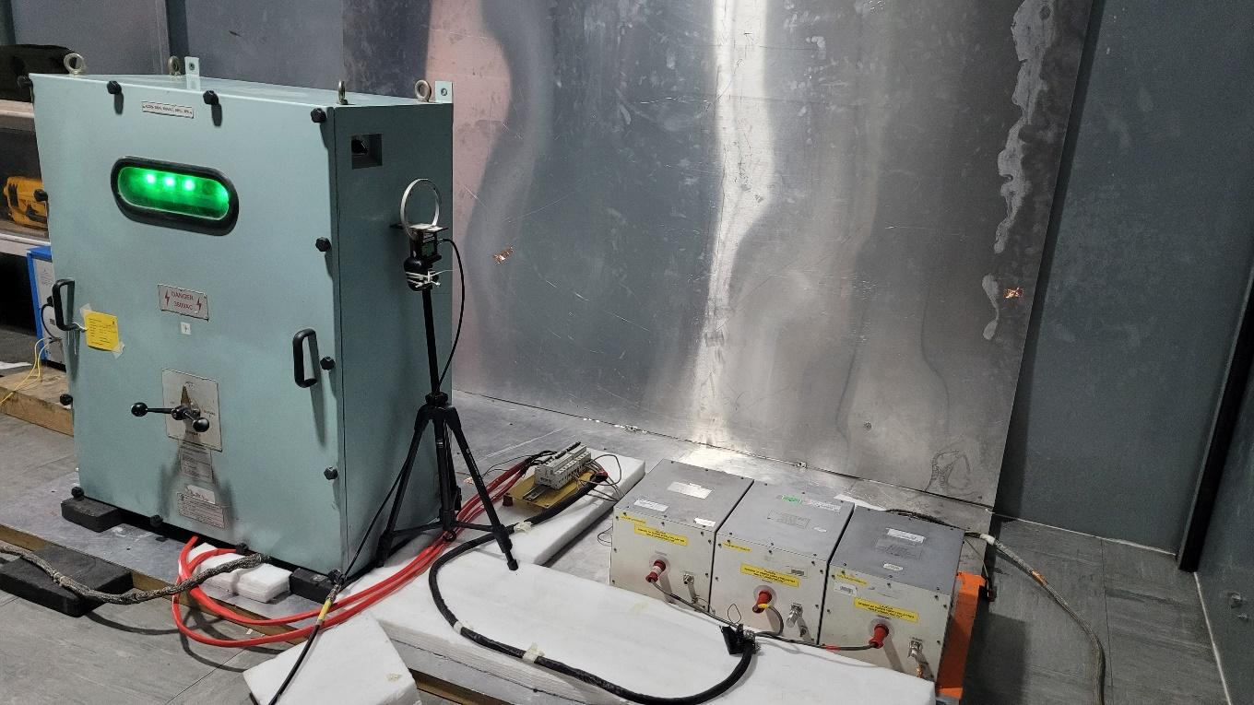

EUT RIGHT

**Figure 11 : RE101 Test Setup Photograph**

|  |  |
| --- | --- |
| **Test Result** | **Pass** |

# Annexure 4: RE102 - Radiated Emissions, Electric field

**Common Information:**

Ref EMC Test Plan : PPPL/EMI-EMC/ACOS(V)2019/02

Test Standard : MIL-STD 461E

Test Date : 30/04/2022

1. Test mode : 380V AC & 9.6 Amps
2. Software used : EMC32 Ver_8.54
3. Temperature : 22.3ºC
4. Humidity : 54%
6. **Test Equipment Used :**

|  |  |  |  |  |  |
| --- | --- | --- | --- | --- | --- |
| **Sl. No.** | **Description** | **Make** | **Model No.** | **Serial No.** | **Cal Due** |
| 1. | Main Chamber | Rain Ford | 467 001 | -- | 02/06/2022 |
| 2 | EMI Receiver | R&S | ESU40 | 100187 | 04/09/2022 |
| 3 | Active Monopole Antenna | A.H. S | EHA 51B | 199 | 09/12/2022 |
| 4 | Biconical antenna | R & S | HK116 | 100133 | 21/12/2022 |
| 5 | Broad Band Horn antenna | Schwarz beck | BBHA 9120F | 9120 F021 | 18/06/2022 |
| 6 | Double Ridged Horn antenna | R&S | HF 906 | 100257 | 18/12/2022 |
| 7 | Preamplifier | R&S | PAM0202 | 316 | 05/12/2022 |
| 8 | Preamplifier | R&S | SCU18 | 10066 | 05/12/2022 |
| 9 | LISN | Solar | 9233-50-PJ-50-N | 98361 & 98363  98362 | 01/12/2023  02/12/2023 |

1. **Receiver Settings:**

|  |  |  |  |  |
| --- | --- | --- | --- | --- |
| **Subrange** | **Detectors** | **IF Bandwidth** | **Meas. Time** | **Receiver** |
| 10kHz-30MHz | Peak | 10 kHz | 0.015s | ESU40 |
| 30MHz-200MHz | Peak | 100 kHz | 0.015s | ESU40 |
| 200MHz-1GHz | Peak | 100 kHz | 0.015s | ESU40 |
| 1GHz-18GHz | Peak | 1 MHz | 0.015s | ESU40 |

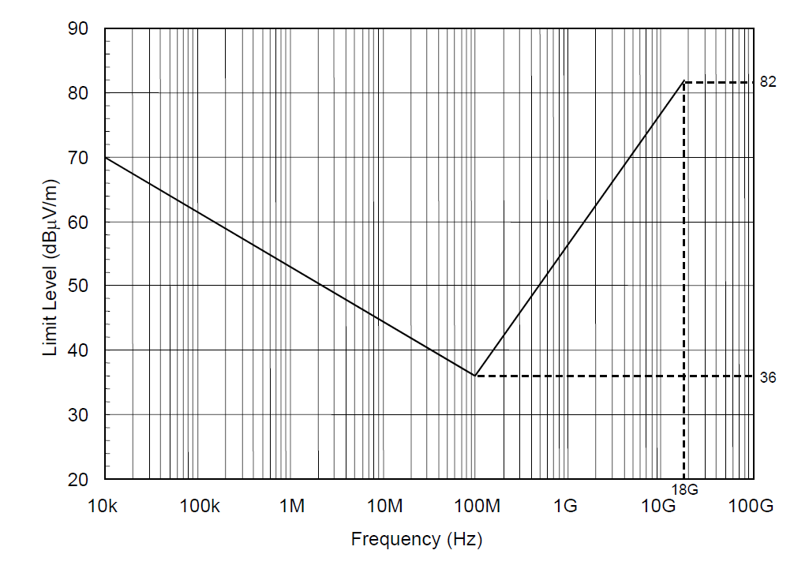

**Figure 12 : RE102-1 Limit Line for Surface Ship Applications**

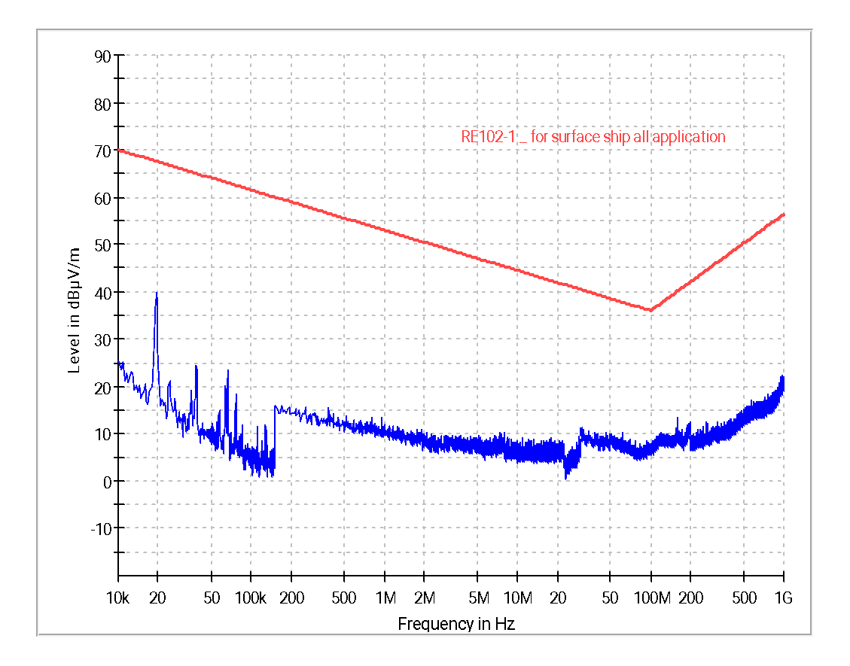

**Graph 21 : RE102 – Ambient Graph**

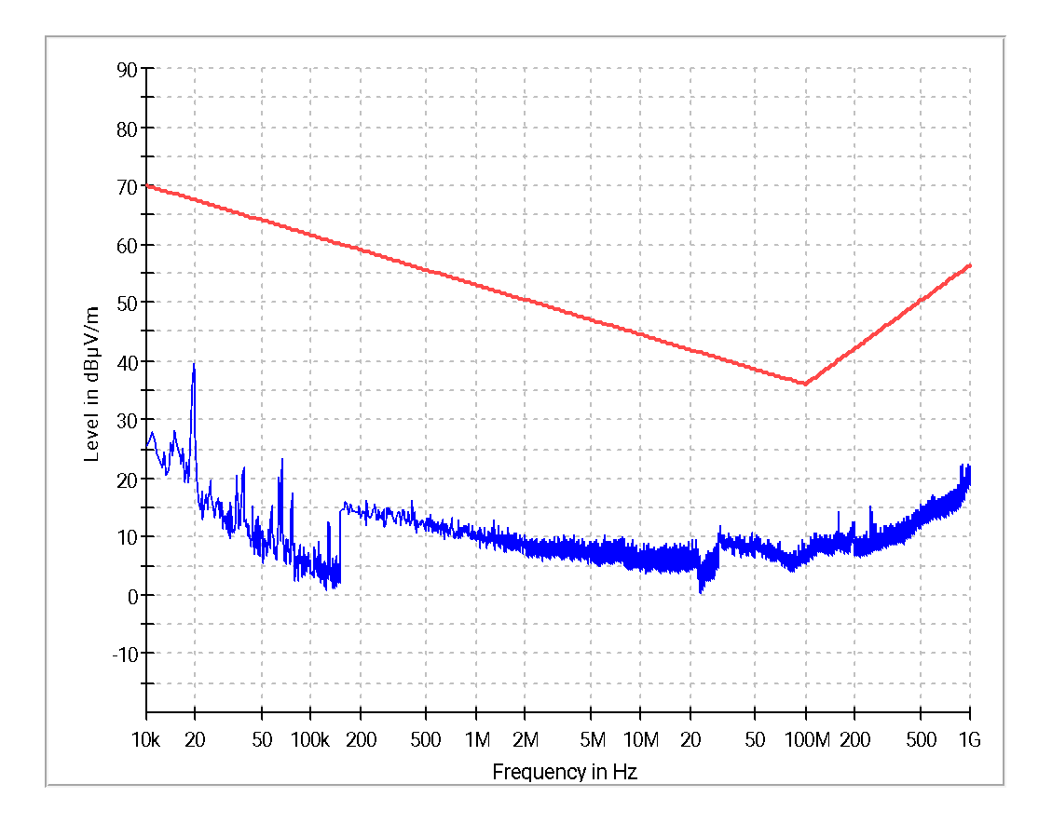

**Graph 22 : RE102 – 10 kHz to 1GHz Vertical Polarization**

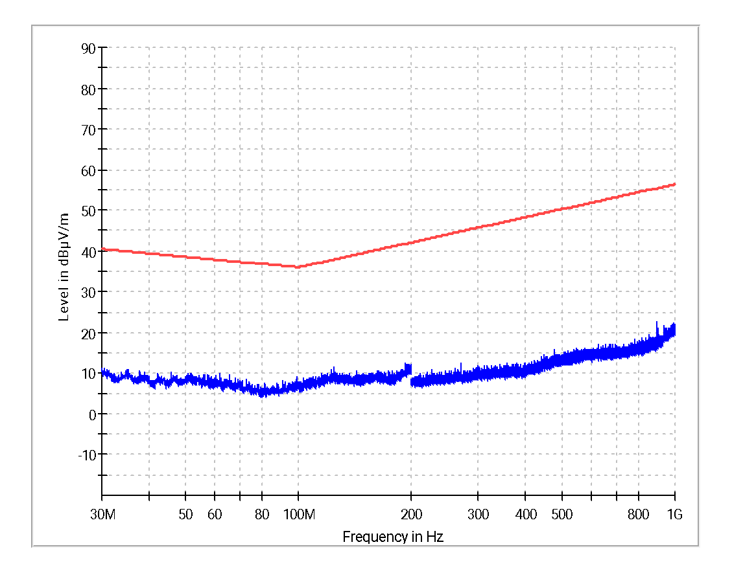

**Graph 23 : RE102 – 30MHz to 1GHz Horizontal Polarization**

|  |
| --- |
| **RE102_10kHz-30MHz** |
| **RE102_30MHz-200MHz** |
| **RE102_200MHz-1GHz** |

**Figure 13 : RE102 Test Setup Photograph**

|  |  |
| --- | --- |
| **Test Result** | **Pass** |



# Annexure 5: CS101 - Conducted Susceptibility, Power Leads

**Common Information:**

Ref EMC Test Plan : PPPL/EMI-EMC/ACOS(V)2019/02

Test Standard : MIL-STD 461E

Test Date : 29/04/2022

Test mode : 380V AC & 9.6 Amps

Software used : EMC32 Ver_10.6

Temperature : 22.0ºC

Humidity : 54%



**Test Equipment Used :**

|  |  |  |  |  |  |
| --- | --- | --- | --- | --- | --- |
| **Sl. No.** | **Description** | **Make** | **Model No.** | **Serial No.** | **Cal Due** |
| 1. | Function generator | Agilent | 33220A | MY44050834 | 22/07/2022 |
| 2. | Audio amplifier | AE Techron | 7224 | 7224-0120-2343 | NA |
| 3. | Audio isolation transformer | Solar | 6220-1A | -- | NA |
| 4. | 10μF Feed through cap. | Solar | 6512-10R | -- | NA |
| 5. | RMS / Peak Voltmeter | R & S | URE-3 | 100806 | 26/02/2023 |
| 6. | Isolation Transformer | Solar | SO-7032-2 | ---- | NA |
| 7. | LISN | Solar | 9233-50-PJ-50-N | 98361 & 98363  98362 | 01/12/2023  02/12/2023 |

**Scan Settings**

|  |  |  |  |
| --- | --- | --- | --- |
| **Subrange** | **Step Size** | **Dwell** | **Modulation** |
| 30Hz- 150kHz | 5% | 3 Sec | CW |

**The test carried out in the following cables**

| **Sl.No.** | **Cable Description** |
| --- | --- |
|  | R-Phase |
|  | Y-Phase |
|  | B-Phase |

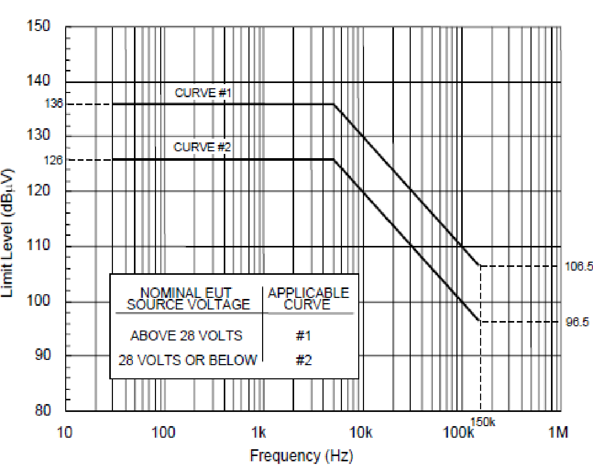

**Figure 14 : CS101 Limit (Curve # 1)**

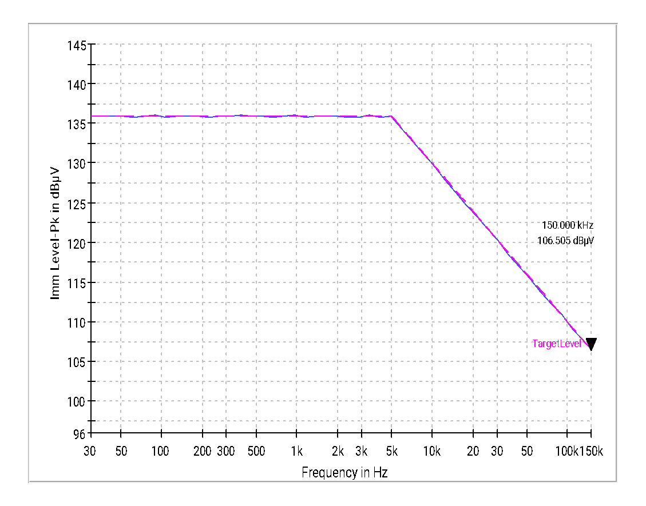

**Graph 24 : CS101 Field Level (dBµV)**

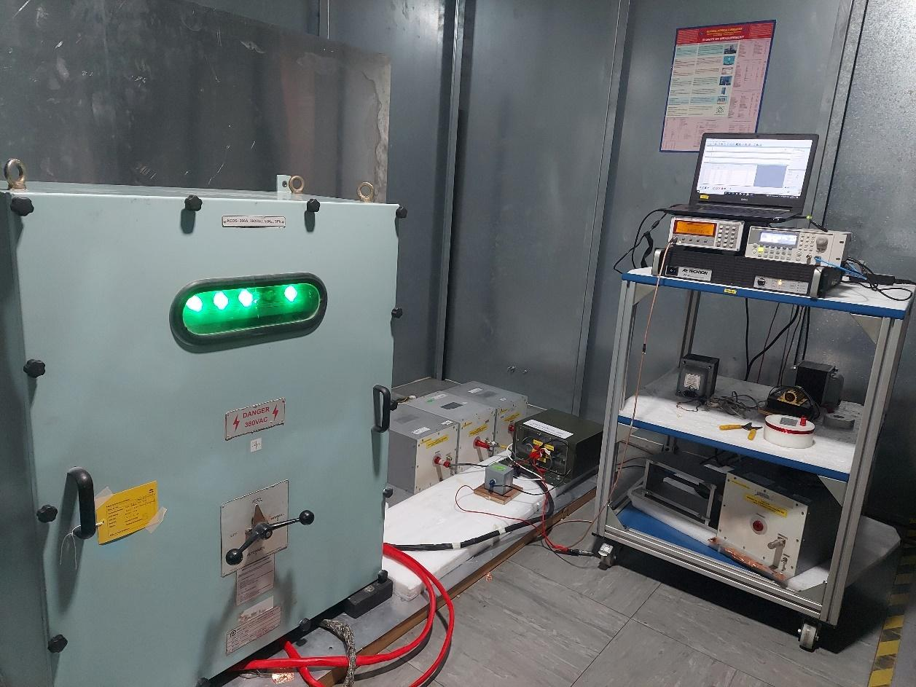

**Figure 15 : CS101 Test Setup Photograph**

|  |  |
| --- | --- |
| **Test Result** | **Pass** |

# Annexure 6: CS114 - Conducted Susceptibility, Bulk Cable injection

**Common Information:**

Ref EMC Test Plan : PPPL/EMI-EMC/ACOS(V)2019/02

Test Standard : MIL-STD 461E

Test Date : 29/04/2022

Test mode : 380V AC & 9.6 Amps

Software used : EMC32 Ver_10.6

Temperature : 21ºC

Humidity : 55%



**Test Equipment Used :**

|  |  |  |  |  |  |
| --- | --- | --- | --- | --- | --- |
| **Sl. No.** | **Description** | **Make** | **Model No.** | **Serial No.** | **Cal Due** |
| 1 | Main Chamber | Rain Ford | 467 001 | -- | 02/06/2022 |
| 2 | EMI Receiver | R&S | ESU40 | 100187 | 04/09/2022 |
| 3 | Signal Generator | R&S | SMB 100A | 103105 | 30/01/2023 |
| 4 | Power Sensor | R & S | NRP Z91 | 101032, 101033 | 06/12/2023 |
|  | Power Amp  (9kHz-220MHz) | Bonn | BTA-0122-3000 | 97674A | NA |
|  | Injection Probe  (0.01 -100MHz) | Solar | 9144-1N | 88535 | NA |
|  | Injection Probe  (2 -500MHz) | Solar | 9142-1N | 98517 | NA |
|  | Current monitor probe | Solar | 9123-1N | 0911109 | 26/04/2022 |
|  | 30dB, 500W Attenuator | Bird | 8325 | 094602171 | NA |
|  | 10dB, 600W Attenuator | Bird | 600-A-MFN-10 | 1478541 | NA |
|  | LISN | Solar | 9233-50-PJ-50-N | 98361 & 98363  98362 | 01/12/2023  02/12/2023 |

**Scan Settings:**

|  |  |  |  |  |
| --- | --- | --- | --- | --- |
| **Subrange** | **Step Size** | **Dwell** | **Modulation** | **Test Curve#** |
| 10kHz- 1MHz | 5% | 3 Sec | PM, 1 kHz 50% duty cycle. | Curve#2 |
| 1MHz- 2MHz | 1% | 3 Sec | PM, 1 kHz 50% duty cycle. | Curve#2 |
| 2MHz to 30 MHz | 1% | 3 Sec | PM, 1 kHz 50% duty cycle. | Curve #2 |
| 30 MHz to 200 MHz | 0.5% | 3 Sec | PM, 1 kHz 50% duty cycle. | Curve #2 |

**The test carried out in the following cables**

| **Sl.No.** | **Cable Description** |
| --- | --- |
|  | Cable Group-1 |
|  | Cable Group-2 |
|  | Cable Group-3 |

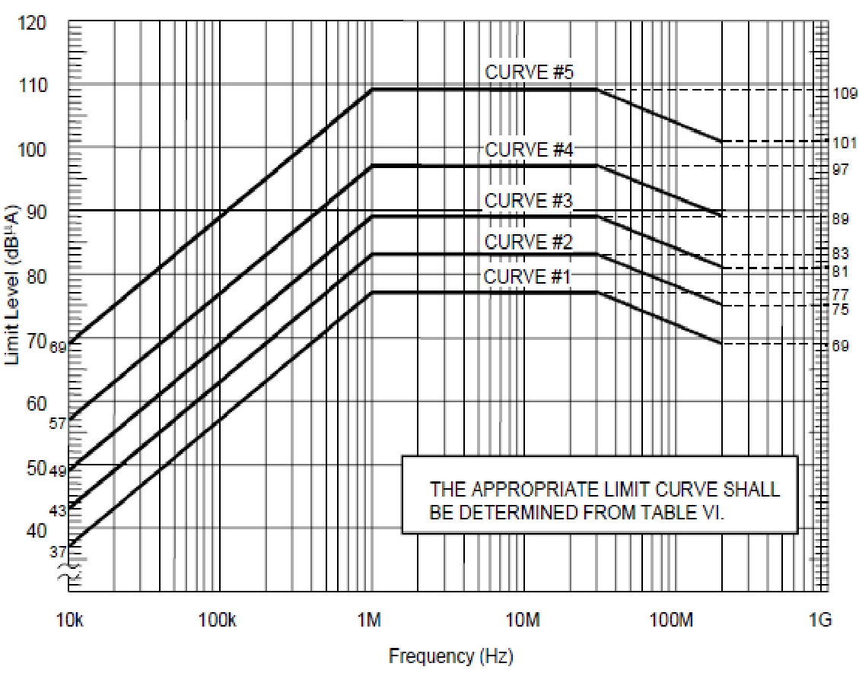

**Figure 16 : CS114 Limit (Curve #2)**

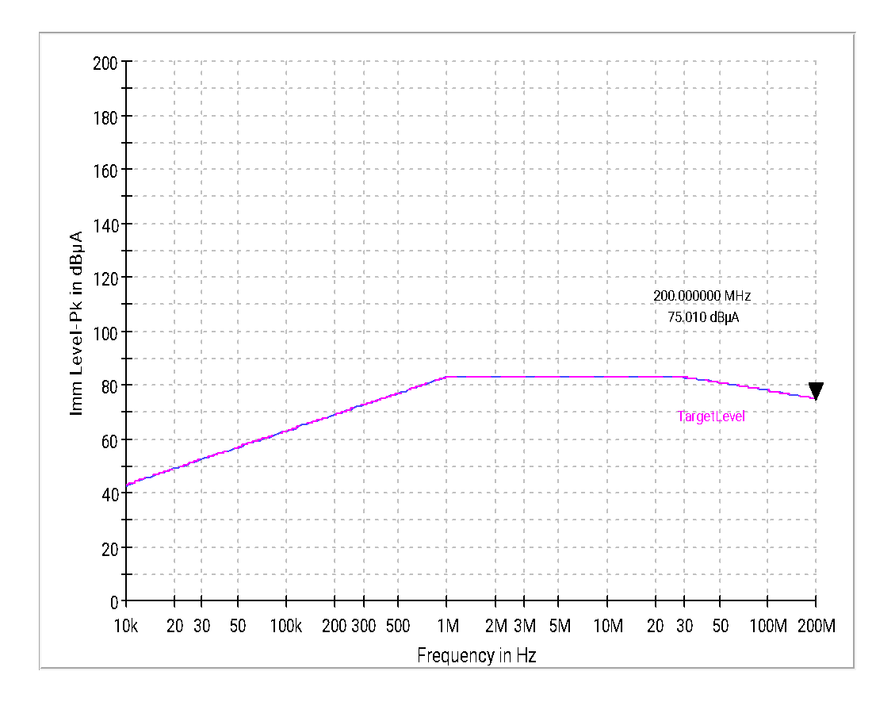

**Graph 25 : CS114 – 10kHz to 200MHz - Immunity Level (dBµA) Curve #2**

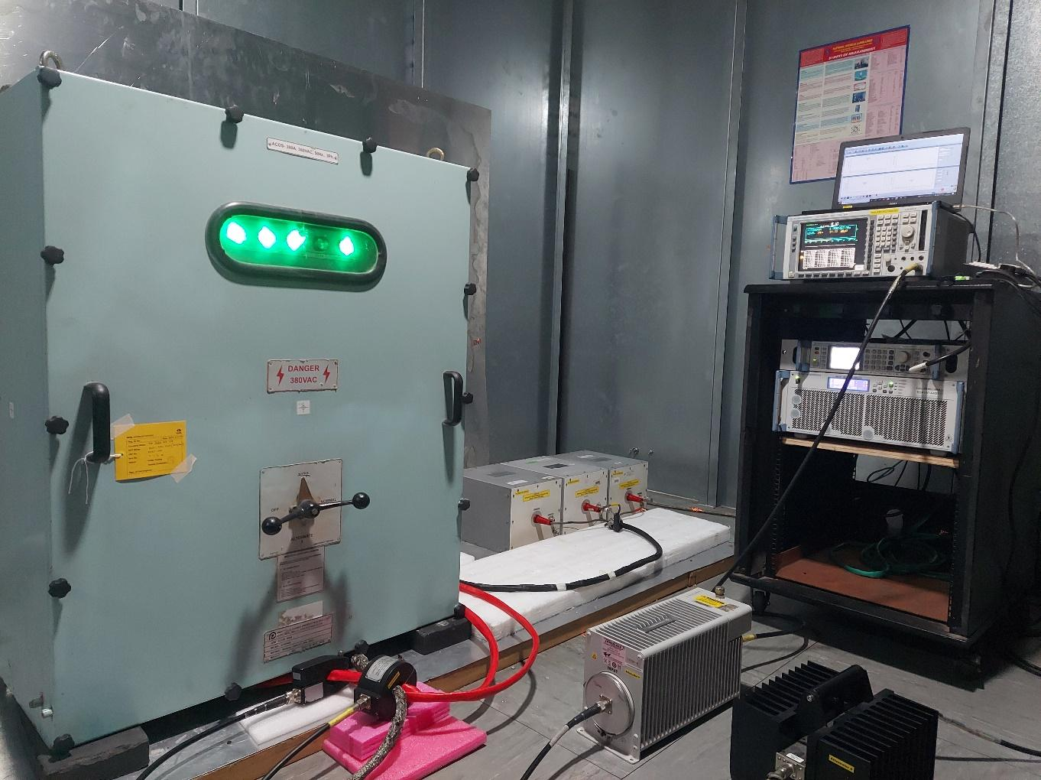

**Figure 17 : CS114 Test Setup Photograph**

|  |  |
| --- | --- |
| **Test Result** | **Pass** |

# Annexure 7: CS115 - Conducted Susceptibility, Bulk Cable Injection, Impulse Excitation

**Common Information:**

Ref EMC Test Plan : PPPL/EMI-EMC/ACOS(V)2019/02

Test Standard : MIL-STD 461E

Test Date : 29/04/2022

Test mode : 380V AC & 9.6 Amps

1. Software used : NA
2. Temperature : 21ºC
3. Humidity : 55%

**Test Equipment Used :**

|  |  |  |  |  |  |
| --- | --- | --- | --- | --- | --- |
| **Sl. No.** | **Description** | **Make** | **Model No.** | **Serial No.** | **Cal Due** |
|  | Modulator Impulse Generator | EMC Partner | MIG-2000-6 | 875 | 07/02/2023 |
|  | Plug in module | EMC Partner | CS115REC | 65 | 07/02/2023 |
|  | Injection Probe | EMC Partner | CN-MIG-BT2 | 73 | NA |
|  | Current Monitoring Probe | Solar | 9123-1N | 0911109 | 26/04/2022 |
|  | Oscilloscope | Tektronix | TDS3052C | C010932 | 22/07/2022 |
|  | LISN | Solar | 9233-50-PJ-50-N | 98361 & 98363  98362 | 01/12/2023  02/12/2023 |

**The test carried out in the following cables**

| **Sl.No.** | **Cable Description** |
| --- | --- |
|  | Cable Group-1 |
|  | Cable Group-2 |
|  | Cable Group-3 |

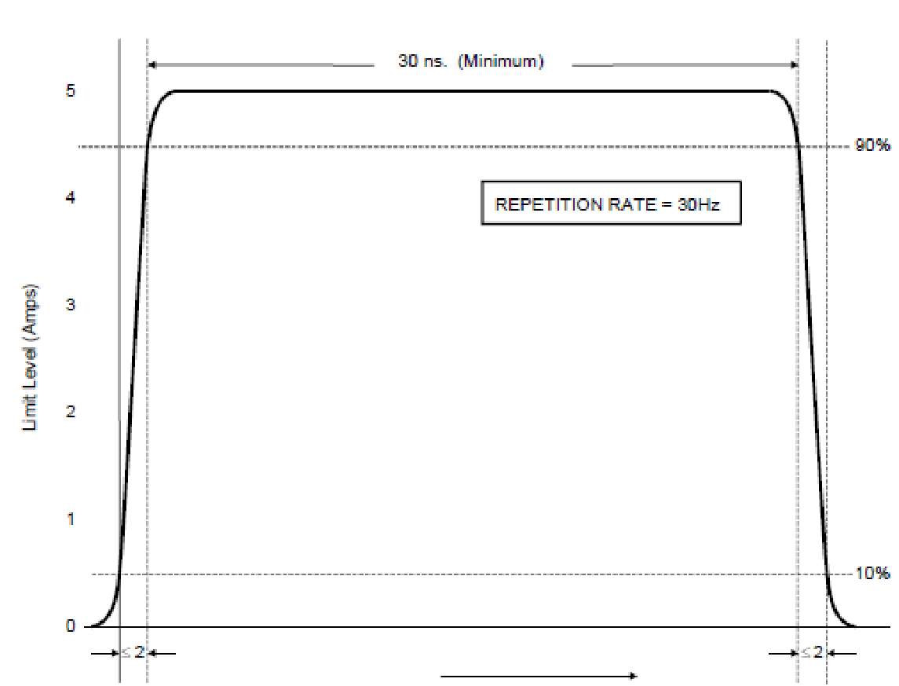

**Figure 18 : CS115 Limit**

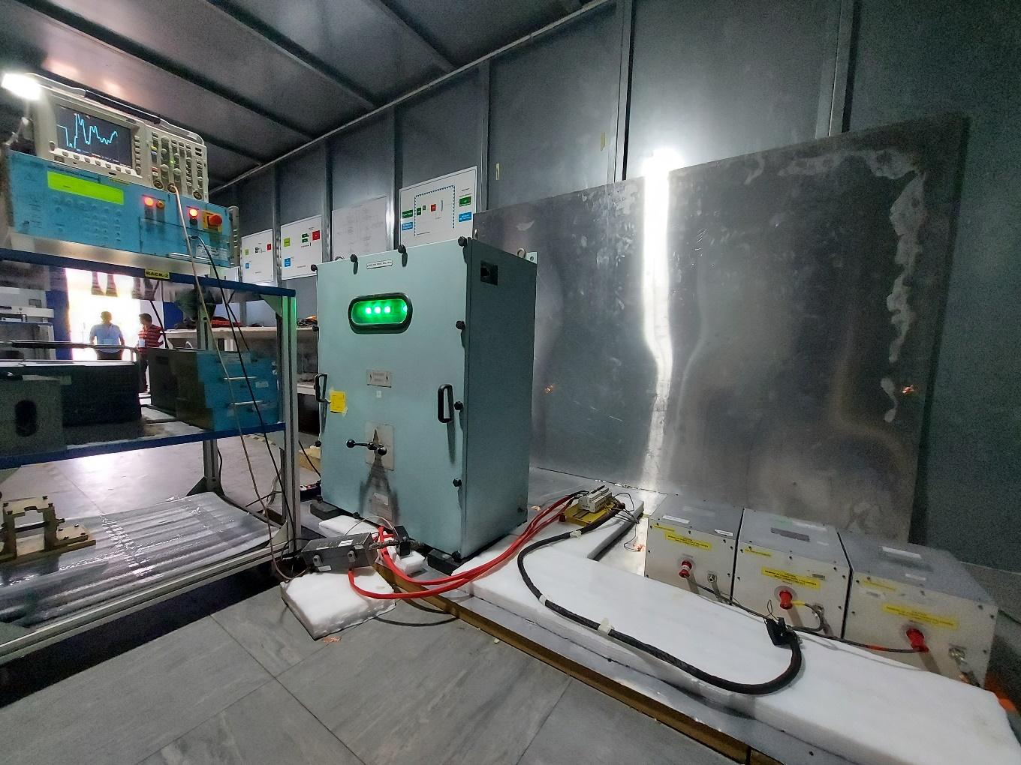

**Figure 19 : CS115 Test Setup Photograph**

|  |  |
| --- | --- |
| **Test Result** | **Pass** |

# Annexure 8: CS116 - Conducted Susceptibility, Damped Sinusoidal Transients.

**Common Information:**

Ref EMC Test Plan : PPPL/EMI-EMC/ACOS(V)2019/02

Test Standard : MIL-STD 461E

Test Date : 29/04/2022

Test mode : 380V AC & 9.6 Amps

Software used : NA

Temperature : 22ºC

Humidity : 55.3%



**Test Equipment Used :**

|  |  |  |  |  |  |
| --- | --- | --- | --- | --- | --- |
| **Sl. No.** | **Description** | **Make** | **Model No.** | **Serial No.** | **Cal Due** |
|  | Modulator Impulse Generator | EMC Partner | MIG-2000-6 | 875 | 07/02/2023 |
|  | Plug in module | EMC Partner | CS116-10k10M | 103586-1567 | 07/02/2023 |
|  | Plug in module | EMC Partner | CS116-30M100M | 78 | 07/02/2023 |
|  | Oscilloscope | Tektronix | TDS3052C | C010932 | 22/07/2022 |
|  | Current Monitoring Probe | Solar | 9123-1N | 0911109 | 26/04/2022 |
|  | Injection probe | EMC Partner | CN-MIG-BT | 101 | NA |
|  | Injection Probe | EMC Partner | CN-MIG-BT2 | 73 | NA |
|  | LISN | Solar | 9233-50-PJ-50-N | 98361 & 98363  98362 | 01/12/2023  02/12/2023 |

**The test carried out in the following cables**

| **Sl.No.** | **Cable Description** |
| --- | --- |
|  | Cable Group-1 |
|  | Cable Group-2 |
|  | Cable Group-3 |

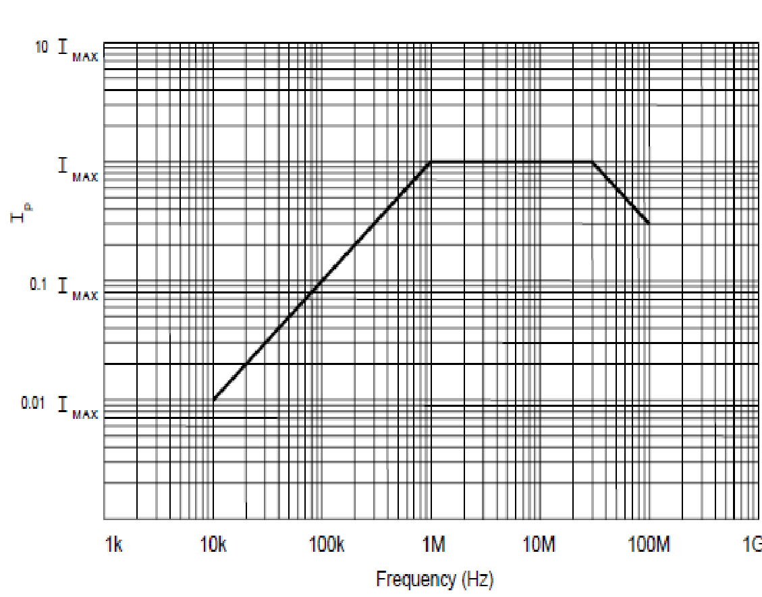

**Figure 20 : CS116 Limit (IMAX – 10 Amps)**

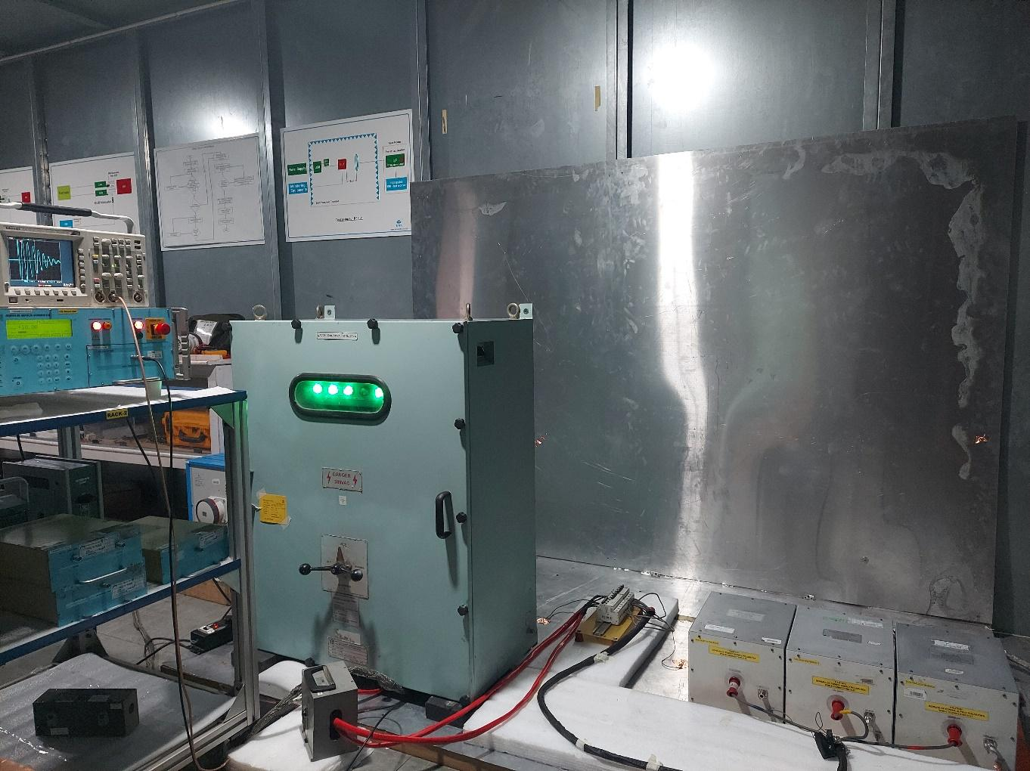

**Figure 21 : CS116 Test Setup Photograph**

|  |  |
| --- | --- |
| **Test Result** | **Pass** |

**Annexure 9: RS101 - Radiated Susceptibility, Magnetic Field**

**Common Information:**

Ref EMC Test Plan :  PPPL/EMI-EMC/ACOS(V)2019/02

Test Standard : MIL-STD 461E

Test Date : 29/04/2022

Test mode : 380V AC & 9.6 Amps

Software used : EMC32 Ver_10.6

Temperature : 23ºC

Humidity : 54%



**Test Equipment Used :**

|  |  |  |  |  |  |
| --- | --- | --- | --- | --- | --- |
| **Sl. No.** | **Description** | **Make** | **Model No.** | **Serial No.** | **Cal Due** |
| 1 | Function generator | Agilent /  Keysight | 33220A | MY44050834 | 22/07/2022 |
| 2 | Audio amplifier | AE Techron | 7224 | 7224-0120-2343 | NA |
| 3 | Radiating loop antenna | Solar | 9230-1 | 087327 | NA |
| 4 | Resistance (2.2Ω) | -- | J0243 | -- | NA |
| 5 | Current Probe | R&S | EZ-17 | 100480 | NA |
| 6 | RMS / Peak Voltmeter | R & S | URE-3 | 100806 | 26/02/2023 |
| 7 | LISN | Solar | 9233-50-PJ-50-N | 98361 & 98363  98362 | 01/12/2023  02/12/2023 |

**Scan Settings:**

|  |  |  |  |
| --- | --- | --- | --- |
| **Subrange** | **Step Size** | **Dwell** | **Modulation** |
| 30Hz- 100kHz | 5% | 3 Sec | CW |

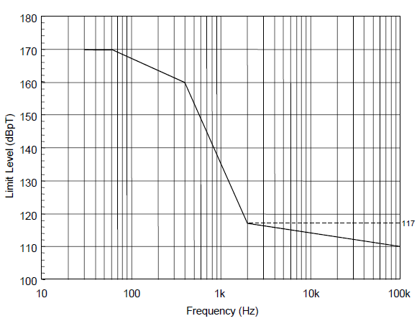

**Figure 22 : RS101 Limit (Navy applications)**

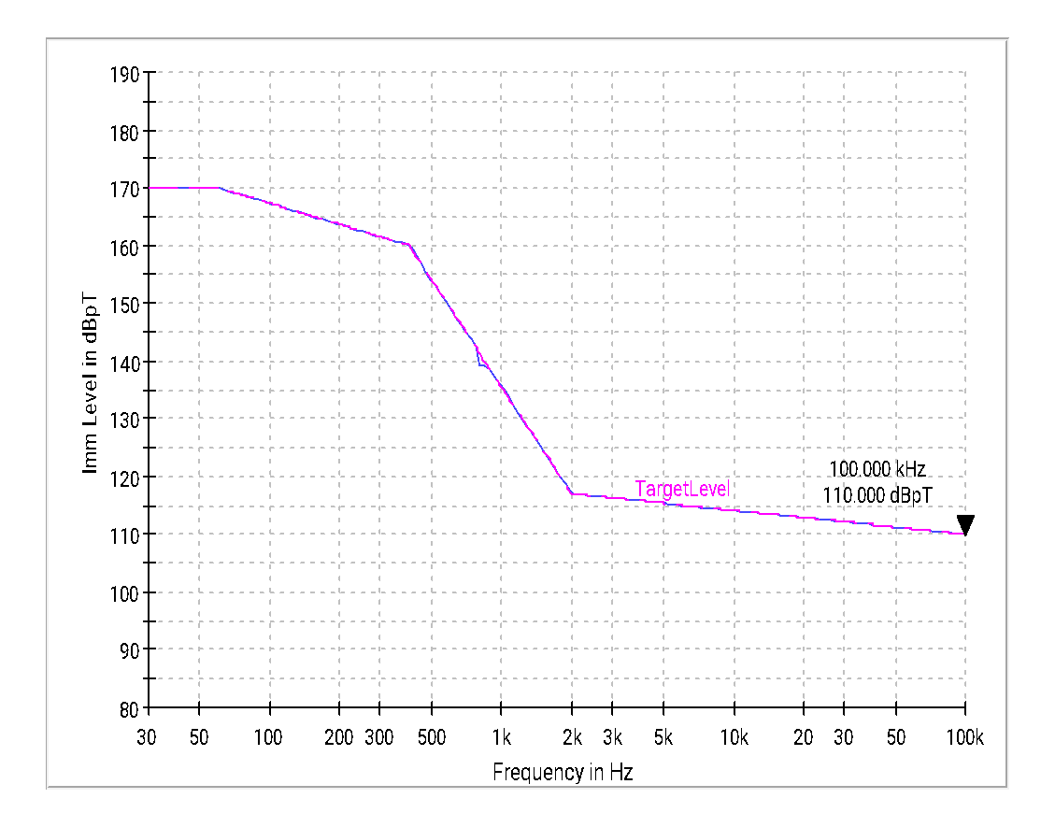

**Graph 26 : RS101 – Immunity Level (dBpT)**

|  |  |
| --- | --- |
| **EUT Front Side** | |
| **EUT Right Side** | **EUT Right Side** |
| **EUT Right Side** | **EUT Right Side** |

**EUT Back Side EUT TOP**

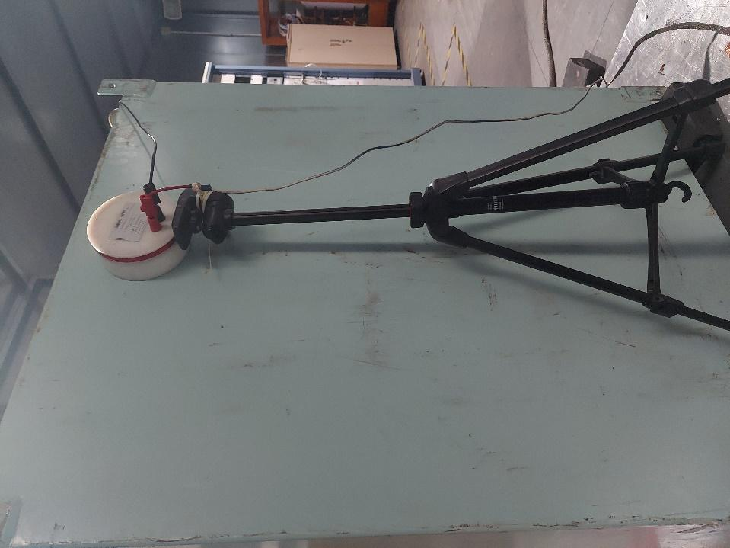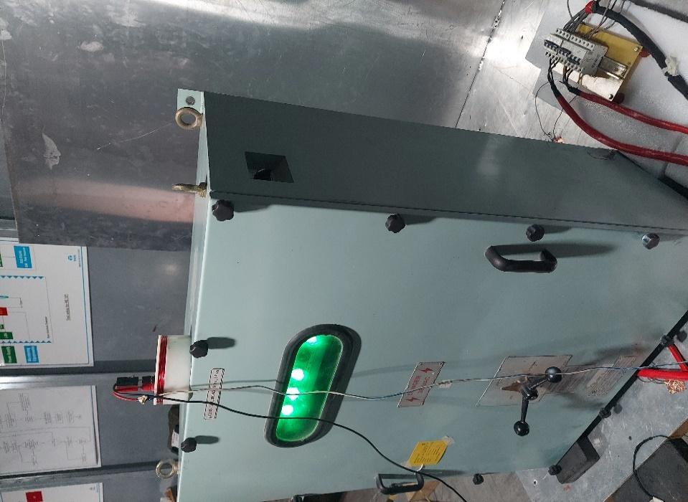

**Figure 23 : RS101 Test Setup Photograph**

|  |  |
| --- | --- |
| **Test Result** | **Pass** |

**Annexure 10: RS103 - Radiated Susceptibility, Electric Field**

**Common Information:**

Ref EMC Test Plan : PPPL/EMI-EMC/ACOS(V)2019/02

Test Standard : MIL-STD 461E

Test Date : 01/05/2022

Test mode : 380V AC & 9.6 Amps

Software used : EMC32 Ver_10.6

Temperature : 24.6ºC

1. Humidity : 60%

**Test Equipment Used :**

| **Sl. No.** | **Description** | **Make** | **Model No.** | **Serial No.** | **Cal Due** |
| --- | --- | --- | --- | --- | --- |
|  | Main Chamber | Rain Ford | 467 001 | -- | 02/06/2022 |
|  | Signal Generator | R&S | SMB 100A | 103105 | 30/01/2023 |
|  | Signal Generator | R&S | SMF 100A | 101313 | 25/06/2023 |
|  | Power Meter | AR | PM2003 | 0580645 | 15/02/2022 |
|  | Power Sensor | AR | PH2004A | 0580797/798 | 17/02/2022 |
|  | Power Sensor | R & S | NRP Z91 | 101032/101033 | 06/12/2023 |
|  | Power Amp (9kHz-220MHz) | Bonn Elektronik | BTA-0122-3000 | 97674A | NA |
|  | Power Amp  (220MHz-1GHz) | Bonn Elektronik | BL 2010-1000D | 97674B | NA |
|  | Power Amp (0.7 - 4.2GHz) | AR | 40S1G4M3 | 0345893 | NA |
|  | Power Amp (4 – 18G) | AR | 20S4G18M5 | 0344002 | NA |
|  | E-H Field Antenna | AR | AT5000M3 | -- | NA |
|  | Log periodic ant.  (80 MHz to 1 GHz) | ETS Lindgren | 3144 | 133330 | NA |
|  | Horn Antenna  (1-18 GHz) | AR | ATH1G18 | 521425 | NA |
|  | LISN | Solar | 9233-50-PJ-50-N | 98361 & 98363  98362 | 01/12/2023  02/12/2023 |

**Scan Settings:**

|  |  |  |  |  |
| --- | --- | --- | --- | --- |
| **Subrange** | **Modulation** | **Step Size** | **Dwell** | **Field level** |
| 2MHz – 30MHz | PM, 50% Duty Cycle,1kHz | 1% | 3sec | 10V/m |
| 30MHz – 80MHz | PM, 50% Duty Cycle,1kHz | 0.5% | 3sec | 10V/m |
| 80MHz – 200MHz | PM, 50% Duty Cycle,1kHz | 0.5% | 3sec | 10V/m |
| 200MHz – 1GHz | PM, 50% Duty Cycle,1kHz | 0.5% | 3sec | 10V/m |
| 1GHz – 18GHz | PM, 50% Duty Cycle,1kHz | 0.1% | 3sec | 10V/m |

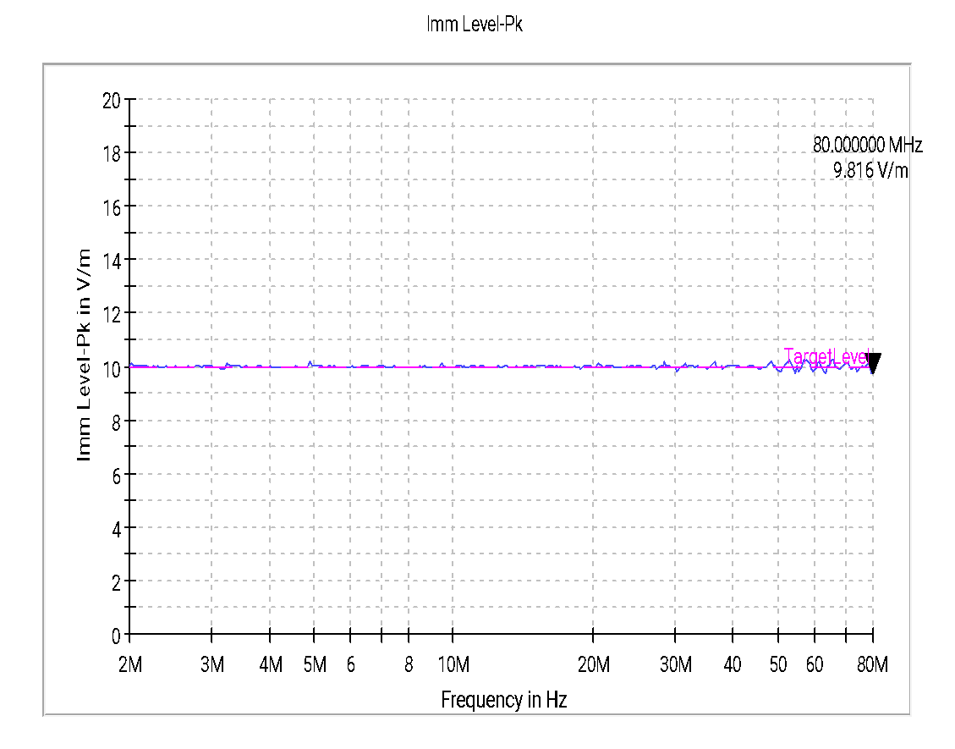

**Graph 27: RS103 –2MHz to 80MHz - Field Strength in V/m**

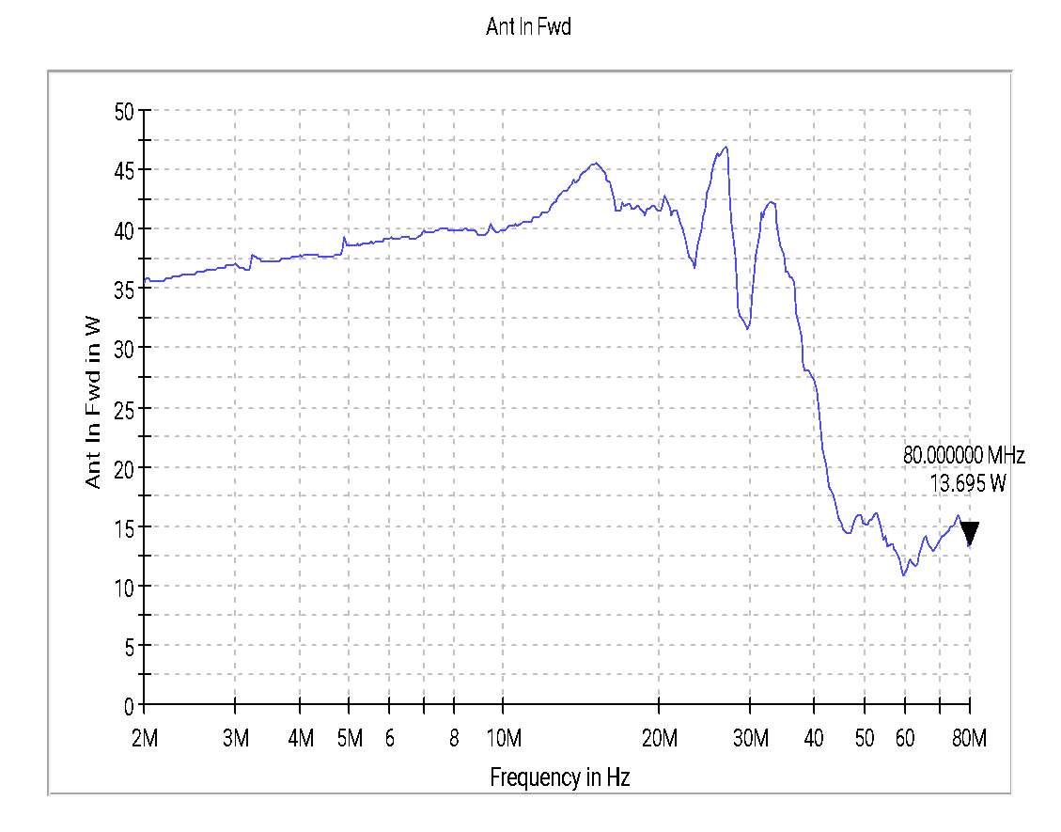

**Graph 28: RS103 –2MHz to 80MHz - Forward Power in Watts**

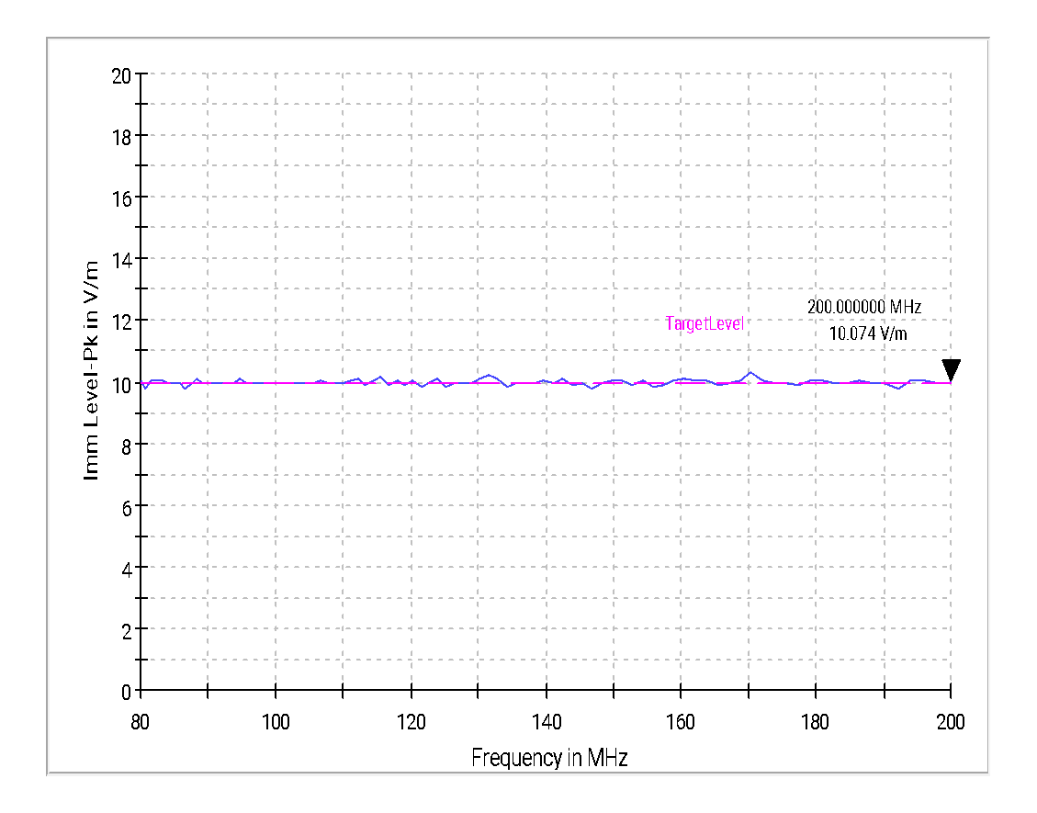

**Graph 29: RS103 –80MHz to 200MHz - Field Strength in V/m**

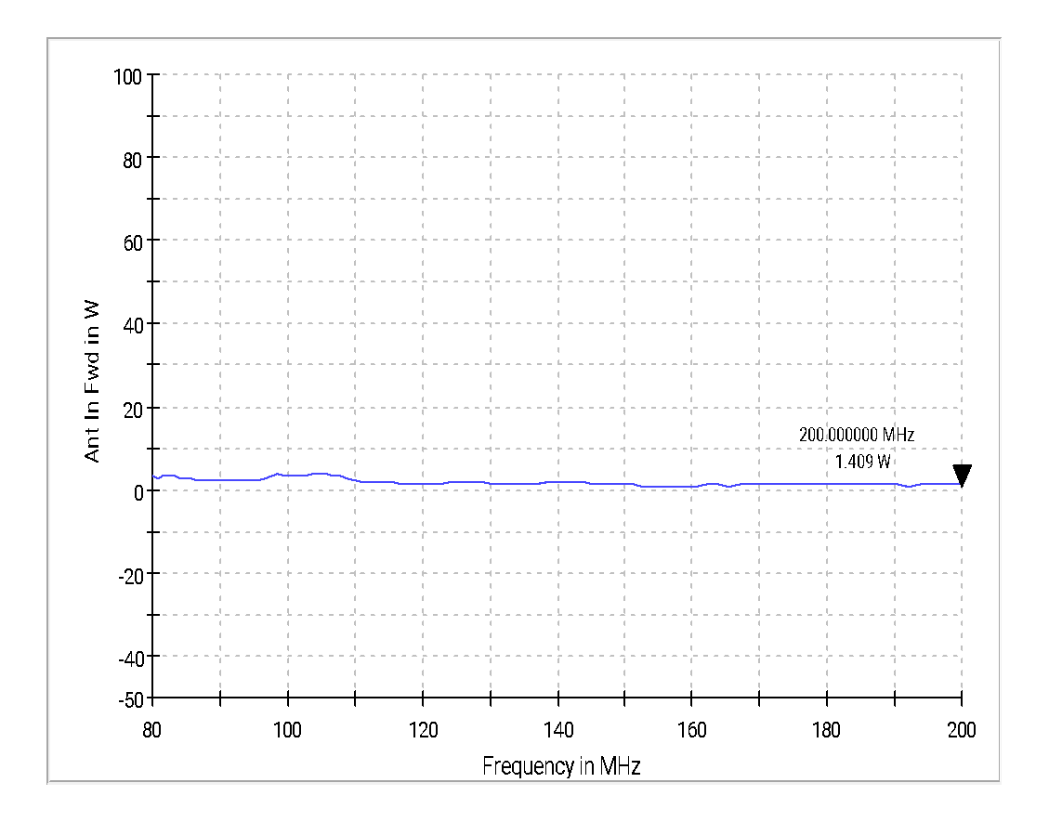

**Graph 30: RS103 –80MHz to 200MHz - Forward Power in Watts**

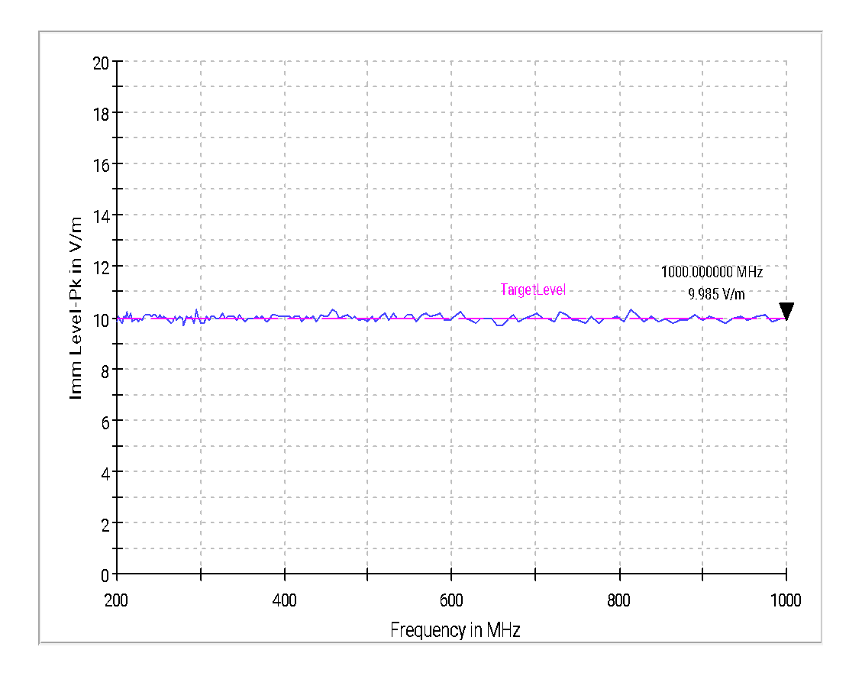

**Graph 31: RS103 200MHz to 1000MHz - Field Strength in V/m**

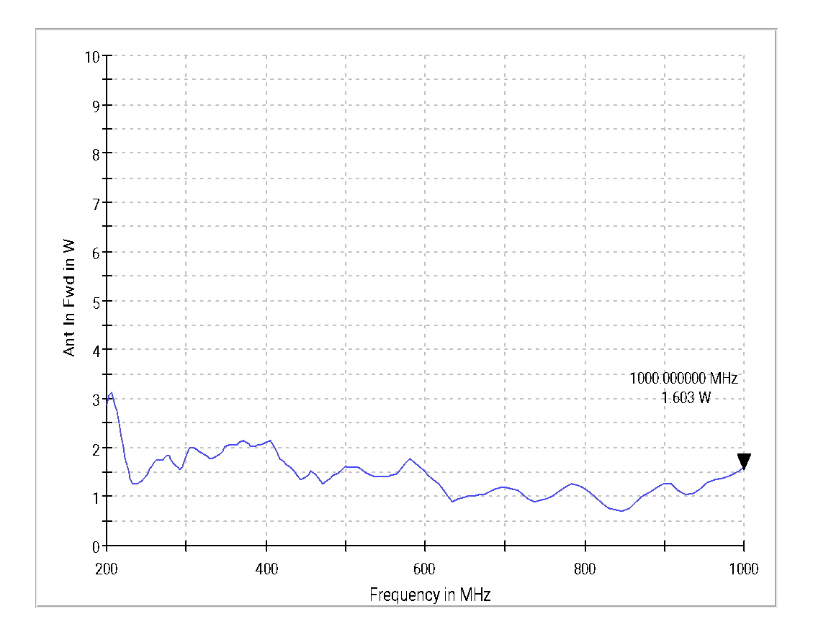

**Graph 32: RS103 –200MHz to 1000MHz - Forward Power in Watts**

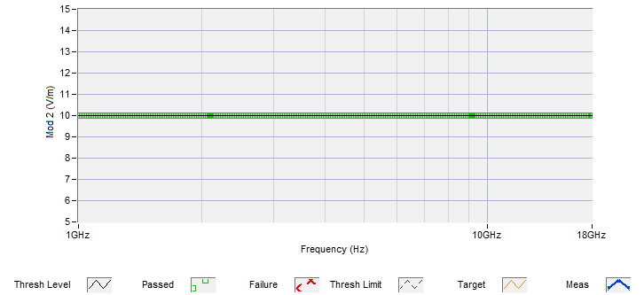

**Graph 33: RS103 –1GHz to 18GHz - Field Strength in V/m**

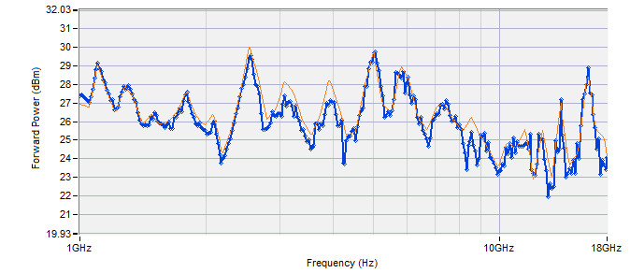

**Graph 34: RS103 – 1GHz to 18GHz - Forward Power in dBm**

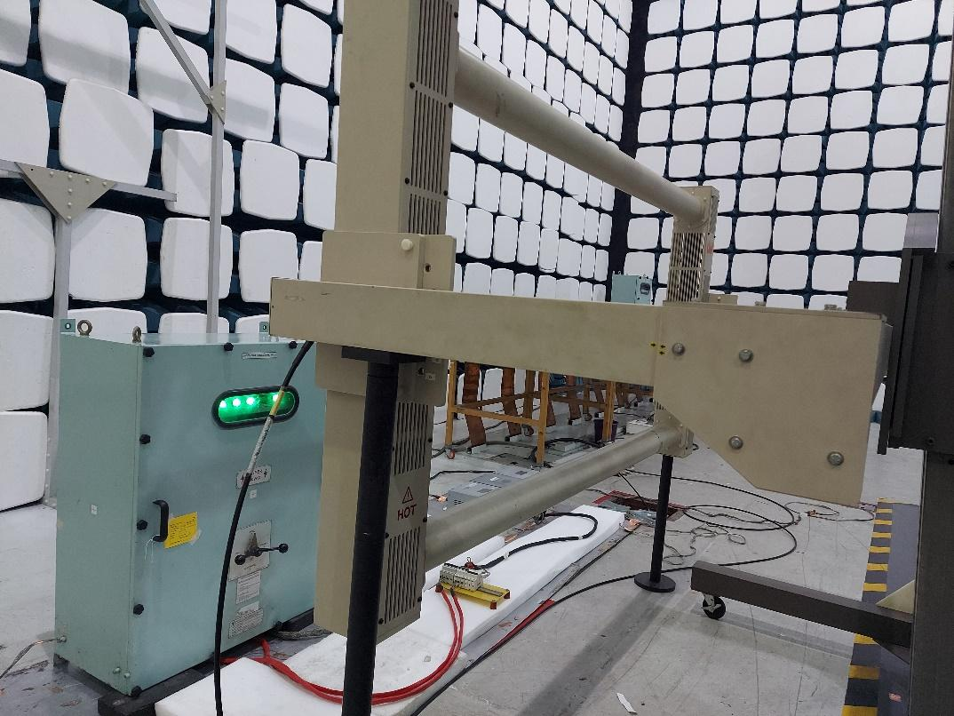

**RS103_2MHz-80MHz**

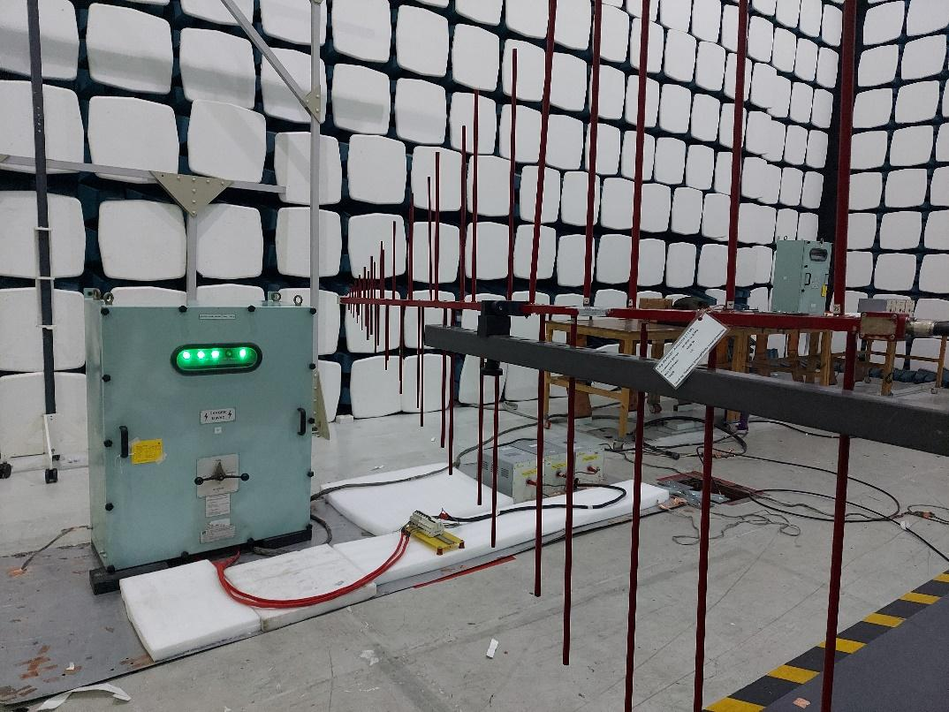

**RS103_1GHz-18GHz**

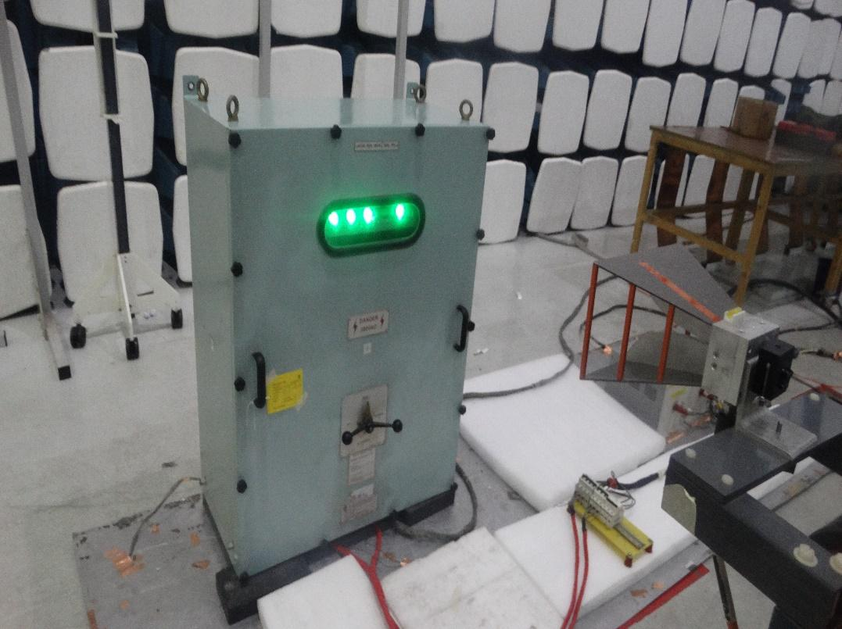

**RS103_1GHz-18GHz**

**Figure 24 : RS103 Test Setup Photograph**

|  |  |
| --- | --- |
| **Test Result** | **Pass** |

**DISCLAIMER**

1. The Released Test Report/s relates ONLY to the specific sample/s tested under the stated conditions and are issued in good faith. It is the Client / Customer’s responsibility to ensure that additional production units of the tested sample/s are manufactured with identical electrical, mechanical and software/firmware components so as to meet the same specifications and quality as the tested sample/s.
2. The Test Reports are issued free of any alterations or additions. Any corrections/erasures invalidate the Test Reports. Tata Advanced Systems does not accept any liability whatsoever for the tampering or any unlawful or inadvertent alteration of documents that have been handed over to the Client / Customer. Any anomaly /discrepancy in the Test report should be brought to the notice of Tata Advanced Systems within 1 (One) Month from the date of issue.
3. Test Reports / Certificates or/and any associated attachments shall NOT be copied/reproduced, except IN FULL, without the prior written consent of Tata Advanced Systems.
4. Every reasonable care is taken to ensure that the Test Reports / Certificates are accurate.   
   Tata Advanced Systems does not accept any responsibility for any consequences arising from the further use of these Test Reports / Certificates or the conclusions and /or opinions drawn from the results of these Tests or investigations by third parties.
5. While every effort is taken by Tata Advanced Systems to ensure that Test Reports are presented to the Customer / Client within a reasonable time, Tata Advanced Systems does not guarantee any turnaround time nor will it be responsible for any late delivery of services because of circumstances beyond its control. In no event will Tata Advanced Systems be liable for damages of any kind, including, without limitation, direct, incidental or consequential damages, including, but not limited to, damages for lost profits, business interruption and loss of programs or information arising out of the use of or inability to use Tata Advanced Systems Test results and / or because of a delay in Tata Advanced Systems providing Test results, or in the Test results or claims attributable to errors, omissions or other inaccuracies in the interpretations thereof. The maximum monetary amount that Tata Advanced Systems would be liable for is reimbursement for the cost of the Tests conducted for Testing services received by Customer / Client. Parties acknowledge and confirm that the Test report citification doesn’t create a warranty that the product(s) tested and certified under this report are better than those not certified.
6. The Customer / Client agrees to indemnify, defend and hold Tata Advanced Systems harmless   
   from and against all losses, expenses, damages, and costs, including attorney fees, arising out of any litigation or relating to any misuse by the Customer / Client of the content and/or services provided by Tata Advanced Systems.
7. Any possible infringement of any patent rights of formulations or processes or any   
   other patent rights are the sole responsibility and liability of the Client / Customer.
8. All services rendered by Tata Advanced Systems will be treated as strictly Confidential.
9. Tata Advanced Systems will respond to clarifications requested by the Client / Customer for a maximum period of 1 (One) Month from the date of receipt by the Client / Customer. Samples will not be retained by Tata Advanced Systems after testing is completed. Soft copies of all Test Reports / Certificates will be retained by Tata Advanced Systems for a maximum period of 3 (Three) Years from the date of issuance of Test Report unless otherwise agreed to by and between the Client / Customer and Tata Advanced Systems.
10. By receiving this report Tata Advanced Systems, the Client / Customer agrees to the terms   
    and conditions of Tata Advanced Systems Laboratory and this Disclaimer.

**End of Test Report**